http://www.USScouts.Org • http://www.MeritBadge.Org
Please submit errors, omissions, comments or suggestions about this workbook to: Workbooks@USScouts.Org
Comments or suggestions for changes to the requirements for the Belt Loop or Pin should be sent to: Advancement.Team@Scouting.Org
Cub Scout’s Name: Pack No. :

Cub Scout Horseback Riding Belt Loop (See the Pin Requirements below.)
Complete these three requirements:
1. Explain five safety precautions for when you are near a horse.
1
2.
3.
4.
5.
2. With help from an experienced horse handler, demonstrate how to safely mount and ride a horse and then how to safely dismount the horse.
3. Go on a supervised horseback ride for at least 20 minutes. Wear an approved helmet (such as one approved for horseback riding by the ASTM, or American Society for Testing and Materials).
Date | Start | End | Duration

Cub Scout Horseback Riding Pin
Earn the Cub Scout Horseback Riding belt loop, and complete five of the following requirements:
1. Learn about three famous horses. Explain why these horses were well-known.
1
2.
3.
2. Using pictures of these different animals, explain to your den or family the difference between a horse, pony, mule, and donkey.
Horse
Pony
Mule
Donkey

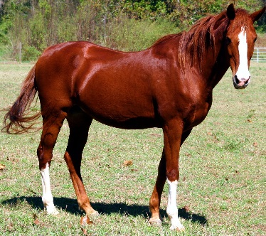 | 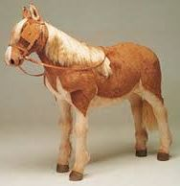 | 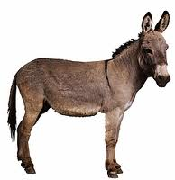 | 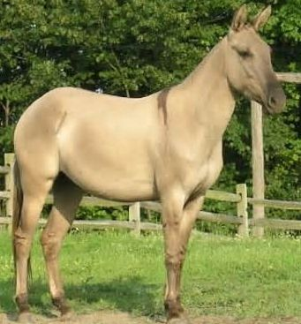
Horse | Pony | Donkey | Mule
3. Explain how a horse is measured and what a “hand” equals when measuring a horse.
4. Using a picture, point out these main parts of a horse: forehead, muzzle, mane, withers, point of hip, knee, hoof, and root of tail.
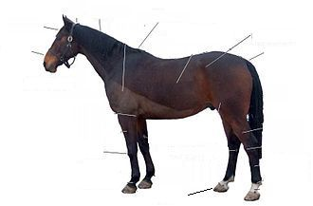
5. Describe three different breeds of horses and explain what feature makes each breed special.
1
2.
3.
6. Using photos or pictures you have drawn, explain to your den or family at least three different ways that horses can help us.
1.
2.
3.
7. Name five things healthy for a horse’s diet.
1.
2.
3.
4.
5.
8 Tell why it is important to wear an approved riding helmet when you go horseback riding.
9. Photograph or draw a picture of the saddle you used for the ride you took to earn the belt loop.
10. With your parent or adult partner, visit a veterinarian who cares for horses. Write the answers to three questions you ask him or her.
 | Question | Answer
1
2.
3.
11. Spend at least 15 minutes before and after your ride getting to know your horse by talking calmly to it and stroking it slowly.
12. Go on a supervised horseback ride for at least 30 minutes. Dress appropriately and show that you can safely mount and dismount the horse.
Requirement resources can be found here:
http://www.meritbadge.org/wiki/index.php/Cub_Scout_Horseback Riding#Requirement resources

Important excerpts from the ‘Guide To Advancement’, No. 33088:
Effective January 1, 2012, the ‘Guide to Advancement’ (which replaced the publication ‘Advancement Committee Policies and Procedures’) is now the official Boy Scouts of America source on advancement policies and procedures.
- [ Inside front cover, and 5.0.1.4 ] — Unauthorized Changes to Advancement Program
No council, committee, district, unit, or individual has the authority to add to, or subtract from, advancement requirements. (There are limited exceptions relating only to youth members with disabilities. For details see section 10, “Advancement for Members With Special Needs”.)
- [ Inside front cover, and 7.0.1.1 ] — The ‘Guide to Safe Scouting’ Applies
Policies and procedures outlined in the ‘Guide to Safe Scouting’, No. 34416, apply to all BSA activities, including those related to advancement and Eagle Scout service projects. [Note: Always reference the online version, which is updated quarterly.]
- [ 4.1.0.3 ] ] — Who Approves Cub Scout Advancement?
A key responsibility for den leaders is to implement the core den meeting plans as outlined in the Den & Pack Meeting Resource Guide, No. 34409. For Wolf, Bear, and Webelos advancement, den leaders take the lead in approving requirements, though their assistants, and also parents who help at meetings, may be asked to play the role of “Akela” and assist. Parents sign for requirements that, according to meeting plans and instructions in the handbooks, take place at home. For the Bobcat trail and Tiger Cub achievements, parents (or adult partners) should sign in the boy’s handbook; the den leader then approves as progress is recorded in the den’s advancement record.
- [ 4.1.0.4 ] — “Do Your Best”
Advancement performance in Cub Scouting is centered on its motto: “Do Your Best.” When a boy has done this—his very best—then regardless of the requirements for any rank or award, it is enough; accomplishment is noted. This is why den leaders, assistants, and parents or guardians are involved in approvals. Generally they know if effort put forth is really the Cub Scout’s best.
- [ 4.1.2.2 ] — Cub Scout Academics and Sports Program
More than just a recognition opportunity, this program develops new skills, improves those existing, and otherwise enriches Cub Scouting. Details can be found in the Cub Scout Academics and Sports Program Guide, No. 34299. Activities include subjects like science, video games, collecting, and chess; and sports such as baseball, skateboarding, and table tennis. Each has two levels—a belt loop and a pin. Belt loops, which can be earned more than once, are awarded when each of three requirements is met. Cub Scouts may then continue with additional requirements and earn the pin. Archery and BB gun shooting are included, but can only be conducted at a council presented activity with certified supervisors.
Additional notes of interest:
- Tiger Cubs, Cub Scouts, and Webelos Scouts may complete requirements for all Academics and Sports Belt Loops and Pins (except shooting sports) in a family, den, pack, school, or community environment. Tiger Cubs must work with their parents or adult partners. Parents and partners do not earn loops or pins.
- “Akela” (Pronounced “Ah-KAY-la”) — Title of respect used in Cub Scouting—any good leader is Akela. Akela is also the leader and guide for Cub Scouts on the advancement trail. The name comes from Rudyard Kipling's Jungle Book. (See "Law of the Pack.")
- “Law of the Pack” — The Cub Scout follows Akela.
The Cub Scout helps the pack go.
The pack helps the Cub Scout grow.
The Cub Scout gives goodwill.

