CORE VALUES
Cub Scout Roundtable Leaders’ Guide
The core value highlighted this month is:
- Positive Attitude: Being cheerful and setting our minds to look for and find the best in all situations. Through participating in a derby, boys will see the importance of having a positive attitude, regardless of the outcome of the race.

COMMISSIONER’S CORNER
Pow Wow Books needed (REALLY NEEDED) I need ideas for Baloo for the Core Values. This month is mainly Pinewood Derby not Positive Attitude. Please help. Thanks to Jim, Pat and Bill, I have Great Salt Lake, Baltimore and Cascade Pacific.
Do Your Best – A Bite at a Time
Alice, Golden Empire Council
Remember that old joke about “How do you eat an Elephant? This month, we can help boys be successful by teaching them to:
* Break a project down into sections
* Learn a new skill to do a project
* Practice the skill on a sample first
We can also teach them about the power of Positive Thinking – every athlete knows that even a difficult task becomes easier and more often fun if they first THINK they can do it and then do their best.
Cub Scouts can learn to take pride in their accomplishments and know that doing their best is more important than winning or losing.
I am looking for different ways to present achievements. So if you have come up with ideas for den meetings centered on the achievements & electives, please email them to davethecommish@gmail.com so we can include them in Baloo. And if you have good ideas for Character Connections, please email those, too.
Well it has been quite a month at Lake Woebegon. OOops, that is Garrison's line not mine. Two camping Trips, Wood Badge staff weekend, RV decided to leak gasoline, and much more. Enjoy Baloo and have a great holiday season.
TABLE OF CONTENTS
In many of the sections you will find subdivisions for the various topics covered in the den meetings
CORE VALUES 1
COMMISSIONER’S CORNER 1
THOUGHTFUL ITEMS FOR SCOUTERS 2
TRAINING TOPICS 2
ROUNDTABLES 2
PACK ADMIN HELPS - 2
LEADER RECOGNITION, INSTALLATION & MORE 2
DEN MEETING TOPICS 2
SPECIAL OPPORTUNITIES 3
100th Anniversary Commemorative Patch 3
Boys’ Life Reading Contest for 2010 5
Knot of the Month 5
GATHERING ACTIVITIES 5
OPENING CEREMONIES 6
AUDIENCE PARTICIPATIONS 6
ADVANCEMENT CEREMONIES 6
GAMES 6
SONGS 7
STUNTS AND APPLAUSES 7
"Applauses & Cheers, Run-Ons, and 7
SKITS 7
CLOSING CEREMONIES 7
Cubmaster’s Minutes 7
CORE VALUE RELATED STUFF 7
DEN ACTIVITIES 7
DEN MEETINGS 9
TIGER 9
WOLF 10
BEAR 19
WEBELOS DENS 21
Core Value: Positive Attitude 21
Den Activities 23
WEBELOS RANK 23
Geologist 24
ARROW OF LIGHT 27
Readyman 29
Arrow of Light Requirements 29
ADDITIONAL ADVANCEMENT IDEAS 31
Tiger Achievements 31
Tiger Electives 31
Wolf Achievements 31
Wolf Electives 31
Bear Achievements 32
Bear Electives 32
Webelos Activity Pins 32
CUB GRUB 32
POW WOW EXTRAVAGANZAS 35
WEB SITES 35
ONE LAST THING 36

THOUGHTFUL ITEMS FOR SCOUTERS
The "Thoughtful Items" and "Quotations" are in the Pack and Leader Hints Edition Dave

TRAINING TOPICS
The "Training Topics" are in the Pack and Leader Hints Edition Dave

ROUNDTABLES
The "Roundtable Hint" is in the Pack and Leader Hints Edition Dave

PACK ADMIN HELPS -
The "Pack Admin Helps " are in the Pack and Leader Hints Edition Dave

LEADER RECOGNITION, INSTALLATION & MORE
The "Leader Recognition" section is in the Pack and Leader Hints Edition Dave

DEN MEETING TOPICS
Wendy, Chief Seattle Council

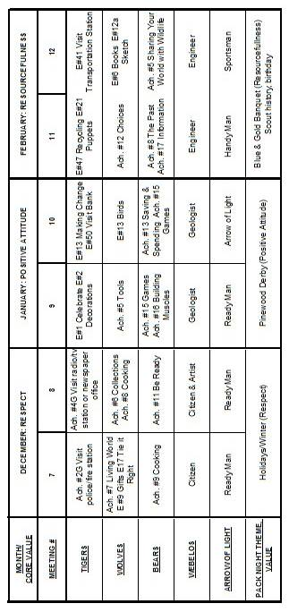
From Bob Scott at National in answer to my question on the role of Roundtables with the new delivery system -
Dave, you have it right.
No changes to roundtable’s role, how it's executed, etc.
Bob Scott , Innovation Coordinator - CS 2010

SPECIAL OPPORTUNITIES

100th Anniversary
Commemorative Patch
www.Scouting.org/100years
A Year of Celebration,
A Century of Making a Difference
Requirements must be completed by December 31, 2010
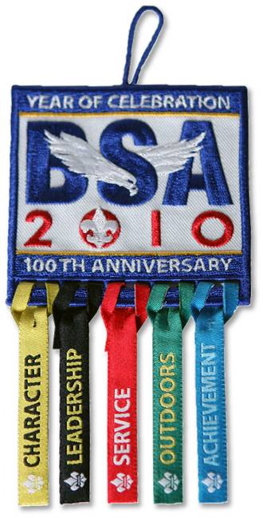
Every Scout, adult leader, and Scouting alum should have the chance to be part of our biggest milestone yet—our 1OOth Anniversary Celebration. Cub Scouts will be a big part of that! We want keep Cub Scouts excited about Scouting while giving them a chance to make a difference—and earn recognition—at an important time in our history. Through A Year of Celebration, A Century of Making a Difference, we will do just that.
By demonstrating dedication to five of Scouting’s core values, Cub Scouts and others can earn award ribbons to hang from the 100th Anniversary Commemorative patch. A Year of Celebration, A Century of Making a Difference is fun, engaging and—most importantly—shows America the impact of Scouting through its commitment to these values. A Year of Celebration will be in effect from Sept. 1, 2009, through Dec. 31, 2010.
Program Objectives
- Provide every Scout, leader, and alumnus a fun and meaningful way to participate in the 1OOth Anniversary and earn recognition!
- Increase awareness of Scouting’s value to the nation by promoting A Year of Celebration activities and by sharing the participation outcomes.
- Engage individuals in fun activities and reward their contributions to Scouting—helping improve both Scout and volunteer retention.
- Spark conversations about Scouting’s values, history, and programs—for both positive public awareness and Scout and volunteer recruitment. The more people talk about Scouting, the more they will want to join in!
- Increase overall participation in our 1OOth Anniversary Celebration by working closely with other national engagement programs.
- Help build stronger local council and unit ties through an exciting and easy-to-use celebration program.
Cub Scout Patch Requirements
National has posted -
Individual Tracking Cards so each Scout can track his progress
http://ww2.scouting.org/100years/100years/sitefiles/1000/YourSource/PlanningTools/YOC/YOC_Tracking_Cards.pdf
Tacking Charts so Dens or Packs can track everyone's progress
http://ww2.scouting.org/100years/100years/sitefiles/1000/YourSource/PlanningTools/YOC/YOC_Chart_Letter.pdf
LEADERSHIP
Scouting has a proud tradition of producing great leaders. Self-determination, teamwork, and preparedness are synonymous with Scouts everywhere. For Scouting’s 1OOth Anniversary, let’s celebrate this tradition of developing youth leaders.
The Year of Celebration Leadership Award encourages Scouts to explore and reflect upon the qualities of a good leader. The award recipients will work on leadership skills. The Leadership Award rewards participants for reflecting upon and sharing leadership lessons and skills. Scouts earning this award will look to role models, lead groups, and participate in leadership-building activities. Adults and alumni will build their unit leadership skills by emphasizing membership growth, volunteering, and providing role models.
Complete three of the five requirements in each category to earn the ribbon.
- Explain what makes a good leader and give an example of a Scout (past or present) demonstrating those qualities. Ask your parent or den leader what makes a good leader.
- Practice being a leader such as being a denner for one week. Write or tell your parent or den leader about what you did during that week.
- Get a friend to join Cub Scouts.
- Organize the den to set up and take down chairs at the pack meeting.
- With the approval of your den leader, plan and lead a den activity.
ACHIEVEMENT
Achievement in Scouting builds self-esteem and fosters collaboration with others. With every rank advanced and award earned, Scouts develop pride in themselves and their units. More than just getting a patch, Scouting’s myriad of awards challenge Scouts to excel, have fun, and grow into healthy, prepared adults. In addition to advancement, the award recipient makes an active effort to reflect on personal achievements and those of other Scouts.
The Year of Celebration Achievement Award highlights the possibilities for personal achievement. Scouts will pursue rank advancements, religious emblems, as well as engage adults and alumni in conversation about their own achievements in Scouting.
Complete three of the six requirements to earn the ribbon.
- Choose something you'd like to do better, and work on it for a week. Write or tell your parent or den leader about your progress.
- Earn one Cub Scout Academics belt loop and one Cub Scout Sports belt loop.
- Complete one achievement or activity badge for your rank.
- Complete one elective for your current rank.
- Complete one Cub Scout Sports or Academics pin, or the BSA Emergency Preparedness Award or the BSA Physical Fitness Award.
- Attend an event at an Adventure Base 100 tour site. Invite and bring a friend with you.
COMMUNITY SERVICE
Scouting’s contribution to society is most visible in the movement’s commitment to community service. Service is interwoven into many of Scouting’s honors and is mandatory for earning the higher rank advancements. Through service, Scouts demonstrate that they provide an essential function to their communities.
The Year of Celebration Community Service Award rewards recipients for providing time and resources at no charge for the good of their local community. More than just engage in service, the award recipient must also share their thoughts about why service is crucial to our society and how Scouts today fulfill a 100-year-old legacy of serving communities.
Over the years, the Boys Scouts of America has partnered with several national organizations to accomplish some great service projects. If you are looking for service project ideas, consider the following options:
Nothing But Nets Scouting For Food
Habitat for Humanity Our National Parks
American Red Cross Arbor Day Foundation
Take Pride in America The Salvation Army
Cell Phones for Soldiers Preserve Our Waterways
2010 US Census
Complete three of the five requirements to earn the ribbon
. * Make sure that all service hours are recorded online for ―Good Turn For America.‖
- With your parent or den leader, identify a person who serves the community. Write or tell about what that person does for others.
- With your family or den, help plan and carry out a community service project. Write or tell about the project.
- With your family and/or den, clean up your Pack’s chartering organization’s parking lot, a neighborhood park, the school grounds, or other public area.
- Participate in a nature beautification project such as a tree or natural vegetation planting.
- Give service to a community organization such as a food bank or feeding station.
CHARACTER
Scouting is a character-building enterprise. Youth learn that personal responsibility and integrity are essential to accomplishing one’s goals. They learn to do good turns without expectation of reward. They learn to be brave when challenged to do the right thing.
The Year of Celebration Character Award rewards recipients for engaging in an active conversation about living by the Scout Law. The award involves elements of citizenship, family life, and personal fitness. Scouts will reflect on their own character and values. Adults and alumni will rediscover the impact Scouting makes on their own character.
Complete three of the five requirements in each category to earn that patch.
- Talk to your parent or den leader about the Cub Scout Promise or Law of the Pack. What does it say about the kind of character a Scout should have?
- With your family or den, plan and carry out a game that helps demonstrate one of the Character Connections(TM). Write or tell about your experience.
- Talk to your parent or rabbi, minister, cleric, or other religious leader about how trust in God provides inner strength and confidence.
- Talk to your parent or den leader about honesty. Talk about why it is important to be honest in everything you say and do.
- Become a friend of a boy who is being left out of the group. Discuss how compassion and cooperation are essential to good character.
OUTDOORS
From campouts to High Adventure, Scouting happens outdoors. Since its inception, Scouting has centered on teaching values through working and playing outside, and fostering respect and understanding of one’s natural surroundings.
The Year of Celebration Outdoors Award is geared toward getting individuals active in nature. The recipients must participate in outdoor activities and show growth in personal outdoor skills. They must also demonstrate increased knowledge of nature. Scouts must show understanding of the impact humans can have on ecosystems and why one must Leave No Trace when experiencing the outdoors. Adults and alumni are encouraged to share their outdoor Scouting experiences with Scouts, as well as non-Scouts of all ages. The Award centers on principles of stewardship, discovery, and personal fitness.
Complete three of the five requirements to earn the ribbon.
- With your family or den, help plan and carry out an outdoor activity. Write or tell about your experience.
- Describe to your parent or den leader the different kinds of plants and animals you can find around your neighborhood.
- Earn Cub Scouting’s Leave No Trace Awareness Award or the Cub Scout Outdoor Activity Award.
- Go on a hike with your family or den.
- Participate in a district or council outdoor experience (day camp, resident camp, etc.).

Boys’ Life Reading Contest for 2010
http://boyslife.org/

SAY ‘YES’ TO READING
Enter the 2010 Boys’ Life Reading Contest
Write a one-page report titled “The Best Book I Read This Year” and enter it in the Boys’ Life 2010 “Say Yes to Reading!” contest.
The book can be fiction or nonfiction. But the report has to be in your own words — 500 words tops. Enter in one of these three age categories:
- 8 years old and younger
- 9 and 10 years old
- 11 years old and older
First-place winners in each age category will receive a $100 gift certificate good for any product in the Boy Scouts official retail catalog. Second-place winners will receive a $75 gift certificate and third-place winners a $50 certificate.
Everyone who enters will get a free patch like the one shown above. (And, yes, the patch is a temporary insignia, so it can be worn on your Cub Scout or Boy Scout uniform shirt, on the right pocket. Proudly display it there or anywhere!) In coming years, you’ll have the opportunity to earn different patches.
The contest is open to all Boys’ Life readers. Be sure to list your name, address, age and grade in school on the entry.
Send your report, along with a business-size, self-addressed, stamped envelope, to:
Boys’ Life Reading Contest
S306
P.O. Box 152079
Irving, TX 75015-2079
Entries must be postmarked by Dec. 31, 2010 and must include entry information and a self-addressed, stamped envelope.
See 2009's winners posted at - http://boyslife.org/home/12652/2009-boys-life-reading-contest-winners/
For more details go to http://boyslife.org/

Knot of the Month
The "Knot of the Month" is in the Pack and Leader Hints Edition Dave

GATHERING ACTIVITIES
"Gathering Activities" for large groups and getting groups to know each other are in the Pack and Leader Hints Edition. Those good for dens (e.g. word searches, puzzles, mazes) are here. Dave
Note on Word Searches, Word Games, Mazes and such – In order to make these items fit in the two column format of Baloo’s Bugle they are shrunk to a width of about 3 inches. Your Cubs probably need bigger pictures. You can get these by copying and pasting the picture from the Word version or clipping the picture in the Adobe (.pdf) version and then enlarging to page width. CD
Pictionary
Cascade Pacific Council
Supplies – Flip chart or large sheets of poster paper, marker
This is a simple game (a commercial version is
available in stores but not needed).
Boys can join in as they arrive at the den meeting.
One member from the den comes up to the den leader, who whispers a word or phrase to him. The den member then goes back to his den and attempts to draw on a sheet of paper, what the den leader said. They are not allowed to give clues by actions, speech, or writing. The first member of the den to guess correctly wins the point.
This could be played with several dens at once al working on the same word or phrase and seeing which den guesses it first. Each den should have its own paper and marker.
Pinewood Derby Logic Puzzle
Cascade Pacific Council
Object: Figure out from the clues the first and last name of each boy, the color of his car, and which race he was in.
Pack 999 had just finished their Pinewood Derby race. It had been a successful night every boy really had had a hand in making his car, no one cried, no Father yelled at the Cubmaster, and very single car made it to the end of the track.
- Bob’s ladybug car raced just before Sam, who raced just before Smith
- Tom and King are BYU fans and so neither one painted his car red.
- Slade had a soccer game and so was late and raced after John
- John and Jones made their cars together and didn’t paint them green.
- Sam used blue spray paint. What a mess he made!!
- The cute yellow taxicab ran in the third race.
Answers:
Race First Last Color
First Bob Jones Red
Second Sam King Blue
Third John Smith Yellow
Fourth Tom Slade Green
Wood
Cascade Pacific Council
Lay out a display of wood samples. You can pick these up at most places that sell wood flooring. Label the samples 1, 2, 3 and so on. On a piece of paper to be handed out list the different kinds of wood you have and a space to put the corresponding number. This will give the boys an opportunity to check out the different types of wood, their textures and pattern designs.
Tools
Cascade Pacific Council
Take several different tools and list them on a piece of paper. Then on a table have these tools set out with #’s by them. See how well they can match them up. Just for fun see if you can find a few old-time tools to identify.

OPENING CEREMONIES
"Opening Ceremonies" are in the Pack and Leader Hints Edition Dave

AUDIENCE PARTICIPATIONS
"Audience Participations" are in the Pack and Leader Hints Edition Dave

ADVANCEMENT CEREMONIES
Journey of 1000 Miles
Immediate Recognition Ceremony for Beads:
Wendy, Chief Seattle Council
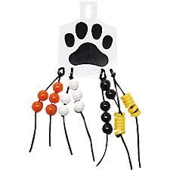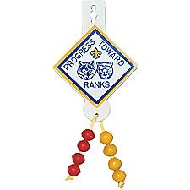
“It is said that the journey of 1000 miles begins with a single step. You have taken several steps on that long journey toward your rank.
To honor your accomplishments, we’d like to present you with your (1st, 2nd, 3rd, 4th) bead. Congratulations!”
Lead den in the Stamp of Approval Cheer: stamp feet several times.
More "Advancement Ceremonies" are in the Pack and Leader Hints Edition Dave

GAMES
Pollyanna's Glad Game
Alice, Golden Empire Council
In the classic children's book Pollyanna, the main character is a young girl who makes a game of positivity, by finding the good in absolutely everything. Her father inspired the game when he helped her deal with a disappointing Christmas gift by finding a reason to be glad. Instead of a doll, she was given crutches. Her father said she could be glad because she didn't need them.
The take-off on this is to create a scenario that seems negative and then talk about it and look for ways to “find the good” in the situation. Scouts can be very creative in looking for and finding a new way to look at something.
Take Another Look - Find the Letter...
Alice, Golden Empire Council
This can be done on-site or as a homework assignment, which would require each boy to take a photo, make a drawing or bring in his examples. The idea is to find every letter of the alphabet – you can use actual letters, but it’s even more fun to look for items that make the “shape” of a letter. You will have to look at ordinary items in a new way – and that’s just what you have to do sometimes to put a Positive spin on what looks like a negative situation!
Display at the Pack meeting – and do make the connection with Positive Attitude!
Here’s a great example, made from photos on an old ranch at a family reunion – just to get you thinking!
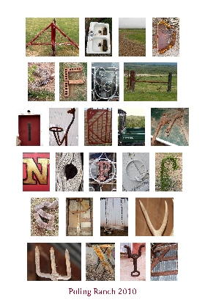

SONGS
Are You Listening?
Wendy, Chief Seattle Council
Tune: Frere Jacques
Are you listening?
Are you listening?
Do you hear?
Do you hear?
From each other we’ll learn.
You talk, then it’s my turn.
One by one,
That’s how it’s done.
Chorus

STUNTS AND APPLAUSES

"Applauses & Cheers, Run-Ons, and
Jokes & Riddles" are in the Pack and Leader Hints Edition Dave

SKITS
"Skits" for the Pack Meeting are in the Pack and Leader Hints Edition Dave

CLOSING CEREMONIES
"Closing Ceremonies" are in the Pack and Leader Hints Edition Dave

Cubmaster’s Minutes
"Cubmaster's Minutes" are in the Pack and Leader Hints Edition Dave

CORE VALUE
RELATED STUFF
Connecting Positive Attitude with Outdoor Activities
Wendy, Chief Seattle Council
(Adapted from B.A.L.O.O. Appendix E)
- Hikes - Have fun even when it is hard to do. If possible, plan a hike that is challenging, lengthy, or has difficult terrain. Have boys explore how to make this a good experience with positive attitudes.
- Nature Activities - Visit a herpetologist or entomologist to talk about how insects and snakes contribute to world ecology. Relate this to having a positive attitude about everyone's place in the world.
- Service Projects - Make cheery cords for others. Mail these to an adopted elderly or shut-in person on a regular basis. Look for opportunities to serve friends or family members who are having a tough time.
- Games & Sports - Bowling and golf are good games that bring the importance of positive attitude to mind. Design a game where boys have to turn "don'ts" and "can'ts" into "do's" and "can's." Always have a good attitude, whether win or lose.
- Ceremonies - Discuss the positive attitude shown by the recipient of a public recognition (especially when it is for advancement).
- Campfires - Use a story about positive attitude. Talk about why we applaud and join in when others are performing. Discuss why it's important not to grumble or complain about your port in a skit or ceremony.
- Den Trips - Visit with someone who has overcome an adverse situation through positive attitudes. Thank others who show a positive attitude when they have to wait in line or take second choice on something.
- Pack Overnighter - Present boys with obstacles to overcome in order for the overnighter to happen (can't get campground we wanted, rain forecast for that weekend, not enough tents or sleeping bags, etc ). Guide them to a resolution, emphasizing a positive attitude.

DEN ACTIVITIES
Alice, Golden Empire Council
Focus on the talents, interests and/or collections of each boy this month – Help each boy learn how to best display his unique talents in an interesting way. Teach boys how to make labels and let them practice explaining their collection or interests at den meetings.
Learn more about people who have shown Positive Attitude throughout history. Boys, dens or families can use a visit to the library or internet sites to find an example that each boy is interested in. Boys could also draw or print a picture of the person and tell or write something of their story for the den or pack meeting.
Challenge each boy or family to tackle a new talent this month – they could take photos, make a display, or tell about what they did to use Positive Attitude in making a change.
Play the Positive Attitude Game – Check it out under the Meeting #9 plan for Bears.
Practice putting a “Positive” spin on everything during the month – If a boy has difficulty doing some requirement, teach him by example to use the words “Next time I could…” or “Maybe it would help if…..” or “Well, at least I did……” Look for opportunities to teach “positive spin” and encourage continued effort – and share the idea with parents so they can do it, too. See how many “positive spin” phrases or ideas the boys can come up with!
During the month, have only treats that start with P or A – or both! See Cub Grub for a list and where to find even more ideas! And each time you eat the treats, remember to mention Positive Attitude!
Pinewood Derby:
Visit a local museum devoted to cars old or new. Go to: www.team.net/www/museums/us.html or www.digital-librarian.com/car_museums.html to access lists of museums in various states and regions.
Check with local car clubs, racing associations, etc. for help in decorating for the Pinewood Derby – they often have large photos or models of cars, racing flags, pennants, and other great stuff. Tip: Check with your local librarian for contacts to local clubs of any kind.
Ring of Fire
Derby Car Display Bear Ach. #22b
Wendy, Chief Seattle Council
The idea behind this display is to make it look like the pinewood derby car is jumping through a ring of flames, or jumping through a ring decorated with a snazzy design (like football players sometimes run through at the beginning of a football game).
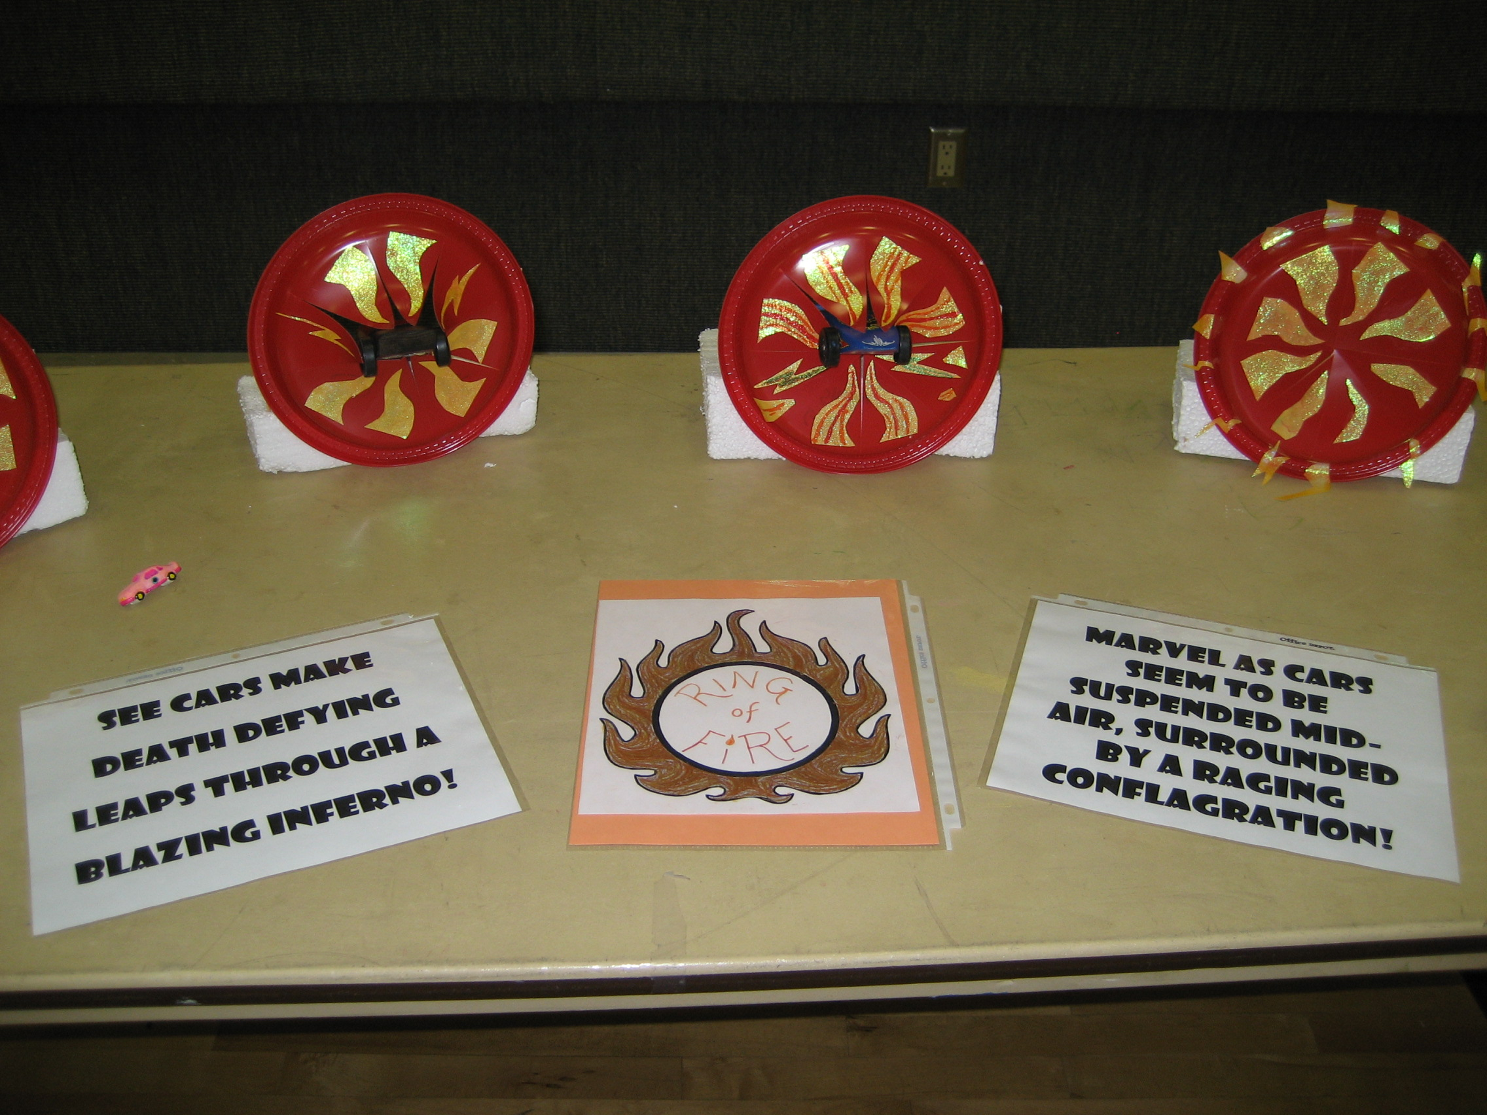
- Cut crisscrossing slits through a large red plastic plate (8 pie shaped wedges), leaving the edges intact.
- Decorate the plate with red, orange, and yellow metallic paint. Or cut out jagged and curvy triangular shapes from orange, red, and yellow mylar or metallic paper (wrapping, or scrapbooking).
- The boys can color the shapes with red, orange, and yellow permanent markers.
- Using glue dots, attach the shapes to the plate to create flames. (Be sure some flames go off the edge of the plate to add to the flaming ring effect.)
- Cut a piece of Styrofoam a little wider that the plate.
- Stick 2 bamboo skewers into the Styrofoam, the width of the plate.
- Cut a straw in half.
- Duct tape a straw to each side of the plastic plate, on the back side.
- Slide the straws over the skewers to support the ring of fire.
- Push the pinewood derby car through the center of the crisscrossing slits.
- Use craft sticks and/or toothpicks to support the car and to keep it from rolling off the Styrofoam block.
- Silver lightning bolts would also look cool on a blue plastic plate.
Tank
Wendy, Chief Seattle Council
- Start with a small square clam shell take-out container.
- Poke a hole in a paper cup (gun turret).
- Insert a straw (gun).
- Tape 2 straws to the bottom of the clamshell.
- Poke a bamboo skewer through a round corrugated cardboard wheel.
- Slide into a straw, and poke the skewer through a second cardboard wheel.
- Repeat with a second skewer and 2 cardboard wheels.
Jet Car
Wendy, Chief Seattle Council
Materials:
2” x 2” x 5” box,
9” balloon,
2 straws 1 ½” long,
1 straw 4” long,
2 wooden dowels 3” long and 1/8” in diameter,
4 milk bottle caps or other lightweight wheels,
2 rubber bands,
Masking tape,
Duct tape,
Hammer and small nail.
Construction:
- Tape the two short straws on the bottom of the box to house the dowel axles.
- Make a small hold in the center of each bottle cap wheel with the hammer and nail.
- Force one wheel onto each axle.
- Wheels should fit tightly. Put each axle through a straw on the box bottom and attach the other two wheels.
- Insert the long straw section into the neck of the balloon about ¾”.
- Duct tape balloon to straw.
- Poke holes in the box so that the straw can mounted at an angle, aiming at the floor.
- Secure with a rubber band.
Use:
- Blow through the straw to inflate the balloon,
- Pinch off the straw to trap the air.
- Set the car on the floor and let it go.

"Pack Activities" are in the Pack and Leader Hints Edition Dave

DEN MEETINGS
Wendy, Chief Seattle Council
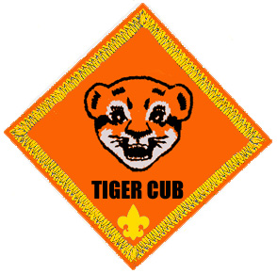

TIGER
Tigers are working on Electives #1,. #2, #13, and 50.
Meeting #9
Do: E. #1 How do you Celebrate?
E. #2 Making Decorations
(for the Blue & Gold Banquet)
Verify Ach. #4F Meal Conversation
Meeting #10
Do: E. #50 Bank Fieldtrip
E. #13 Making Change

Blue & Gold Banquet Ideas
See ideas in the 2010 “Happy Birthday BSA” theme.
- http://kismif.org/2009/07/25/2009-program-helps-full/
- http://www.scoutingthenet.com/Training/Roundtable/Handouts/10/01/
Paper Garland (Chinese Banner):
- http://familyfun.go.com/crafts/chinese-banner-665046/
Hint - Use blue & gold paper.
Centerpieces:
- http://www.makingfriends.com/scouts/scouts_boys_blue&gold.htm
Spin Art Invitations:
- http://www.makingfriends.com/spin_art_invitations.htm
Money Ideas
Money Games, Treats, Crafts & Activities:
Baloo's Bugle for the March 2002 theme, "Dollars and Sense" http://usscouts.org/usscouts/bbugle/bb0202.pdf
This was the only month I could find where there was money related theme. CD
http://www.scoutingthenet.com/Training/Roundtable/Handouts/02/02/
2002 Santa Clara “Dollars & Sense” p. 10.
2002 Tatanka “Dollars & Sense” p. 6-7.
http://familyfun.go.com/playtime/making-sense-of-money-787575/ http://familyfun.go.com/playtime/show-them-the-money-706420/
http://familyfun.go.com/playtime/dollars-and-sense-706658/
Crafts:
Meeting #9:
Pinewood Derby Display Stand
Alice, Golden Empire Council
Elect. #2 – Make some decorations – boys could work on decorations for the Pinewood Derby – An adult could make this simple stand for each boy’s car, then each boy can decorate his own stand with stickers, permanent markers of stencils. On Derby Day, the cars on their stands become part of the decoration – and stay safe from damage!
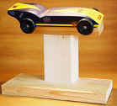
This stand is made from a 1X3 inch piece of wood for the base, a short length of 2/X4 inch for the upright, (if you cut an angle on the front side of this piece, the car will sit angled and look really GOOD!), and a piece of 1X2 inch wood for the top that holds the car.
For more details, go to:
www.pinewoodpro.com/pinewood-derby-car-stand.htm
Personalized Plates
Alice, Golden Empire Council
Each boy could design his very own Vanity Plate – have a License Plate shape ready – boys use first pencils, then markers, stickers, stencils to make their own design. Adult Partners can help them think of a play on their name or initials, then use their favorite things or places as the background.
You could also let siblings make their own license plate designs on race day.
Or have some extra fun by covering just the name on each license plate, and let everyone else try to match boys with their designer plates.
See item on making license plates from soda cans
(or pop cans, if you are from Indiana) CD
Meeting #10:
Tyvek Wallet:
Wendy, Chief Seattle Council
Have your Scouts make a wallet and use it for
play money as you do the advancements
Materials
- 11-1/2- by 10-1/2-inch piece of Tyvek (the durable material often used for envelopes)
- Painter's tape
- Paper
- Clear contact paper or packing tape
- Markers (optional)
A. Fold the Tyvek into thirds lengthwise (A).
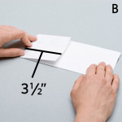
B. Fold over a 3-1/2-inch section (B).
C. Fold over the remaining section so that its edge meets the first fold (C), then unfold it.
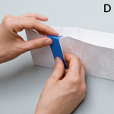
D. Create the card pocket: line up a length of painter's tape with the edge of the shorter flap and wrap the tape's ends around the top and bottom edges of the billfold as shown (D), without sealing the opening. Wrap the side and bottom edges of the wallet with tape.
E. Add a photo and a word balloon with clear contact paper or packing tape. Decorate the wallet with tape or markers. I taped an acetate square to the inside of the wallet to make a picture pocket. (Instead of taping a picture to the inside of the wallet using clear packing tape.) Wendy
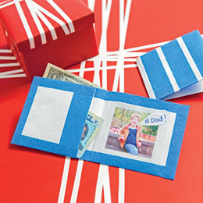

Quarter Keeper
Wendy, Chief Seattle Council
Hook it to your backpack and you'll always
have a quarter or two.
Materials
- Red, White and Black Craft Foam
- Plastic Clip
- Low Temp Glue Gun
- 1/8" Hole Punch
- (1/4" Punch will work also)
- Scissors
- Pattern for Pokeball
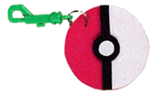
Instructions:
- Print pattern for quarter holder. Make sure red and white circles are large enough for a quarter.. You could change colors to Blue & Gold.
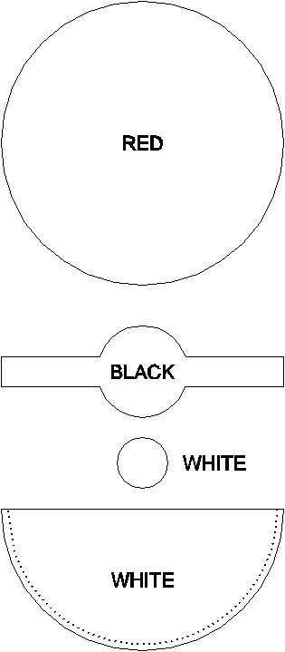
- Cut foam pieces using pattern as a guide.
- Glue the black band to the top of the white ball half.
- Glue the small white circle in place on the black band.
- To make the pouch, run a bead of glue along the back of the white ball half where indicated by the dotted line.
- Line the bottom of the white piece up with the bottom of the red piece.
- Let dry.
- Punch hole near the top of the ball about 1/2" from edge.


WOLF
Wolves are working on Ach. #5, Ach. #10, Ach. #11, and #. #13.
Meeting #9 Tools
Hardware Store Fieldtrip
DO: Ach. #5a Point out and name 7 tools.
Ach. #5b Show how to use pliers.
Ach. #5c Identify and use screwdrivers.
Ach. #5d Show how to use a hammer.
Ach. #5e Build something.
Maybe the bird house for E.#13f below, or a pinewood derby car)
HA: Ach. #10a-g Family Fun,
Ach. #11a-d Duty to God,
E. #13c Bird Book.
Note: E.#3 Make it Yourself
works nicely with the Tool achievement.
Places to Go
Lowe’s Free Saturday Kids’ Workshops:
https://lowesbuildandgrow.com/Home.aspx
Home Depot Free Kids Workshop:
http://www.homedepot.com/webapp/wcs/stores/servlet/ContentView?pn=Kids_Workshops&langId=-1&storeId=10051&catalogId=10053&cm_mmc=THD_marketing-_-Clinics_site-_-Digitas-_-KidsClinics
Meeting #10 Birds
DO: E. #13a List birds seen during the week, and where they were..
E. #13b Pont out 10 different kinds of birds.
E. #13e Feed the birds.
Ach. #10a Cooperation Character Connection Discussion.
Note: the only way the boys can pass off Ach. #10a
at den meeting is if their parents attend den meeting.
This achievement is to be discussed with the
boys’ families.
Verify Ach. #10a-g Family Fun
Ach. #11a-d Duty to God
E. #13c Bird Book.
HA: E. #13a Bird Watching Chart.
E. #13f Birdhouse.
Note from Wendy -
In many parts of the country, January is not the most auspicious month for bird watching. Consider doing den meeting #11 instead, to make sure your boys finish up their achievements so they can get their rank patches at the Blue & Gold Banquet. Or start preparing for the Blue & Gold Banquet. (See Blue & Gold Banquet ideas below.)
Tool Ideas
Games:
http://usscouts.org/usscouts/bbugle/bb0602.pdf ’06 Baloo’s Bugle “Cubstruction” p. 17-19.
http://www.scoutingthenet.com/scouting/Training/Roundtable/Handouts/06/02/
- ’99 Cubstruction Pow Wow Book p. 13-14.
- Pack 114 Round Table Hand Out, p. 11.
“Go the Distance” Minute to Win It Game: http://www.nbc.com/minute-to-win-it/how-to/episode-120/go-the-distance/
Nail Driving Contest I
Baltimore Area Council
Object: To be the first team to drive nail into wood.
Materials: Scrap wood and 10-penny nails. A hammer for each team.
- Divide the den into teams.
- In front of each boy place a hammer and a piece of scrap wood with a 10-penny nail already started a half-inch into it.
- Boys take turns hammering the nail until the head is flush with the wood.
- This is not a speed contest. Fewest strokes wins.
- If the nail is bent, start over with a new one.
Name That Tool
Baltimore Area Council
Trace silhouettes of tools (such as a hammer, plane, brace bit, screw driver, etc.) on paper. Challenge boys to identify the silhouetted tools.
Kim’s Game with Tools
York-Adams Area Council
Spread out about 15 tools on a table. Give the boys the opportunity to study them carefully. Have one of the boys go away from the group. Remove one of the items from the table and hide it. Have the boy return and try to guess what's missing. If he guesses, he then picks the next victim. If not, he goes again. Rotate through the den until everyone has had a turn (or two).
Achievement 5b, c, and d
Gathering Activity: To ease time pressures in den meeting #9, do Ach. #5b, c, d as gathering activities. Have the boys hammer a nail into a scrap piece of lumber, and remove it with the claw. The boys can use the nail hole for the screw (5c).
Jeopardy-style “Name that Tool”
Put 7 or more tools on a table. Divide the boys into teams. Ask them Jeopardy-style questions. (Example: “I make wood smooth.”) The first boy to raise his hand gets to answer. (Points to sandpaper or file.) Award one point for selecting the right tool; award a second point for correctly naming the tool. Highest score wins.
Wood Projects Wolf Ach. #5e, E3e
Pencil Holder:
Cut 2”x2” into 5” lengths. Drill holes for pencils & pens. Sand or file rough edges smooth. Paint or decorate as desired.
Book End:
Cut 1” board into 4” and 6” pieces to make L-shaped book ends. Sand or file rough edges smooth. Nail together. Glue felt to bottom of book end. Decoupage pictures to bookends, or paint.
Picture/Recipe Holder (Wolf Ach. #3a):
Cut 2”x 2” into cubes. Sand or file rough edges smooth. Using pliers, coil one end of a 9” length of plastic coated bell wire into a flat spiral. (Spiral is essentially a big round, square, or diamond shaped paper clip.) Hammer nail into cube and remove to create hole. Dip straight end of wire into tacky glue, and push into hole in cube. Paint or decorate cube as desired. Place picture in spiral.
Make a Den Doodle –
Alice, Golden Empire Council
Create a Den Doodle to showcase what the boys have done – discuss with the den how they would like their Den Doodle to look. You can also use hand tools that the boys identify (Ach. #5a) to make the doodle – saws, screw driver, hand drill, nails, sandpaper, stencils for lettering, paint and paintbrushes – and let every boy do part of the work! (One of my son’s dens chose to use a shark for their “logo”)
The Doodle is shown off at every pack meeting – a visual record of accomplishment! So this project is also an example of Positive Attitude – the Value for January! When a boy is done with the rank, his lacing and beads can go with him.
Each boy has his own length of lacing, and beads can be added for each field trip, achievement, elective – use pony beads, make your own, or even use special “beads” to fit the situation, such as a bear claw for earning the Bear badge. To personalize the boy’s length of lacing, have each boy bring a frozen juice lid, paint them and add a school picture to the center – so everyone will know who’s who!
Make a Shadowbox – Ach. #5a, c, d, e
Alice, Golden Empire Council
Another project using tools – and allowing for Positive Attitude - would be to have each boy make a shadowbox – then it can be used to display patches earned during the Cub Scout years! While making the Shadowbox, each boy could identify and use a tape to measure, a carpenter’s pencil to mark edges, a mitre box (if you make a box with mitred corners), carpenter’s glue, a screwdriver and screws to make the box, and small nails and a hammer to add the backing.
Field Trip Idea:
Alice, Golden Empire Council
- Visit a local home improvement store and look for tools and supplies.
- See if there’s a pack Dad or Grandad with a shop – especially if you aren’t a handyman yourself! I took my den to a local woodworker’s home shop, and he not only explained all his tools – he got all the supplies for a set of bookends and helped the boys complete their project!
Bird Ideas
Activities with Others
San Gabriel Valley, Long Beach, Verdugo Hills Councils
The Great Backyard Bird Count. Although this annual event sponsored in part by the Audubon Society is held in February for people all over the country record bird sightings and report on-line to scientists at www.birdsource.org . The website has other birding activity suggestions for year round.
Project Feeder Watch. Set up a bird feeder and observe and count the birds that come to eat in your own yard. Check out the website for more details:
www.birds.cornell.edu
And maybe you want to help at the World Series of Birding You can put a team together and compete or you could help out a competing team with their logistics for the day.
http://www.njaudubon.org/WSB/
Elect. #13c – (Homework)
Alice, Golden Empire Council
Read a book about birds – but also look for examples of how each bird shows a “positive outlook” – using the smallest bits of “trash” to make a nest, singing to greet the day.
Field Trip Idea:
Alice, Golden Empire Council
- Visit a local library so the boys can learn how items are arranged, what kinds of other things are available (it’s not just books!); If there is a children’s librarian, let her know what the boys are supposed to do for the elective – she can help them learn how to find what they need.
- See if there’s a pack parrot or friend who actually has birds – another den leader with a macaw once brought her bird to share with all the boys – it was a great hit!
Attracting Garden Birds
Sam Houston Area Council
When you make a special effort to identify the types of birds that inhabit your neighborhood, you will begin to recognize individual birds as old friends, and you will find yourself noticing interesting details about their behavior. You can start by taking a little trouble to attract birds to your garden even if you live in a town and the garden in only a small yard.
Build a bird table by nailing a large tray on top of a tall and unpainted wooden post that is standing up firmly in the ground—and out of reach of the local cats. Birds appreciate drinking facilities, and a place to bathe, so use (or make) a tray that is big and strong enough to support a shallow dish of water, which you must not allow to get too dirty.
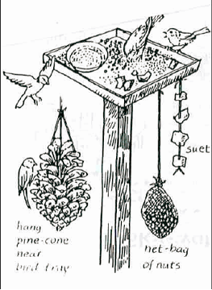
Start to feed the birds in early autumn, and keep putting out fresh food throughout the winter. Provide more variety than bread crumbs. Avoid salty things. Various species of birds will eat boiled potato, melon and sunflower seeds, crushed dog-biscuit, chopped apple and oatmeal.
Smear a paste of bird seed and peanut butter onto a pine cone suspended from a string. Other things to hang up are crusts of bread and the hard animal fat—perhaps from a butcher’s shop—known as suet. You can also buy a net bag of nuts to hang under the tray.
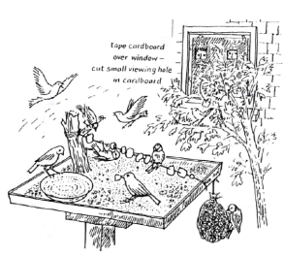
Do not put your feeding station where birds will be continually disturbed by people. You might be able to convert a nearby window into a viewing “hole” by fixing up a sheet of cardboard with a slot to look through.
Questions and observations
Sam Houston Area Council
Get to know the names of the types of birds that visit your bird table. Use a good book with colored pictures. Visitors may include the robin, sparrow, finch, cardinal, blackbird and blue jay. Other visitors will depend on where you live and the time of the year. Activity will be brisk during a severe weather—you can consider designing a bird table with a roof. (image 3)
Notice how the different species approach your feeding stations. Do they fly up from the ground, from shrubbery nearby, or do they fly directly down? Do they come alone, or in groups? Which types of birds are “bullies”? How well do the birds get along with each other? Does a bird have special way of eating its food? Is there a connection between birds’ beaks and the food they choose?
FIELD TRIPS
Heart of America Council
Visit an aviary at the zoo.
Visit a wild life sanctuary
Visit an Audubon Society site
SERVICE PROJECTS
Heart of America Council
Collect food for animal shelter.
Clean up a park.
HIKES
Heart of America Council
Bird Watching Hike: Describe the birds seen; size, coloring, beak type,, and where they are. Take a bird identification book or someone who knows birds.
Rules for Bird watching:
Heart of America Council
- Look at the bird, not the field guide. The book will still be there in a few minutes, but the bird will move.
- Avoid brightly colored clothes. Many birds have poor color vision but they'll see high contrast clothing.
- Be quiet.
- Avoid sudden movements - move slowly and smoothly.
- Get the sun at your back.
- Wait for the flicker of motion, then look there.
- Work the flocks - a bunch of white-crowned sparrows may have something else among them.
- Follow your ears. One calling bird can lead you to a whole group.
- Look all around you - overhead and on the ground, as well as in the trees and bushes.
- Try "spishing". Small birds are attracted to small squeaky noises. Make noises by kissing the back of your hand or making a low whistled noise through your closed teeth. Or clench your teeth, open your lips, and whisper the word "spish". A more sophisticated variant on this technique is to play a tape recording of an owl and wait for 'birds to come investigate this potential danger.
Mother’s Nature’s Housing Developments: How many animal homes can be found on the hike. Look for bird nests, cliff or barn swallows nests, squirrel nests, cocoons, insect galls, spider webs paper wasps nests, mud douber wasps’ nests, woodchuck burrow. It’s fair to count evidence of homes such as little mud casts made by earthworms and a long raised mound across a lawn made by a burrowing mole. A hollow tree might be the home of several animals – woodpeckers, owls, bats, or white footed mice. In a pond is near by, look for mud chimneys of crayfish built near shore. Award a prize to the boy who finds the most animal homes. Caution the boys not to remove or destroy these homes.
Pringles Can Feeder:
Sam Houston Area Council
- Randomly cut 6 or so 1/2" holes in the sides of the Pringles can at various heights from bottom.
- Punch a couple of small holes near the top of the can and insert an appropriate length of coat hanger to serve as the feeder hanger.
- Wrap the can with heavy aluminum foil (temporary).
- Heat 1/2 lb suet with 1 cup wild bird seed in a double boiler.
- Pour into Pringles can and let cool.
- After cooling, remove the foil and hang.
- Watch the birds as they come for this treat
How To Make A Chicken(Turkey) Call:
Baloo’s Archives
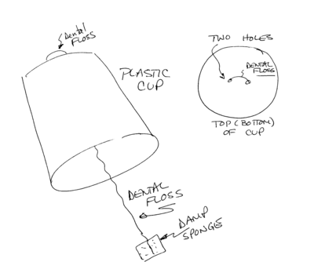
Material:
1 – 12 or 16 ounce plastic cup
1 – two to three foot long piece of dental floss
1 – 1 inch (approx) square piece of sponge
tape
Directions:
- Poke two small holes in the top of the plastic cup
- Thread the dental floss up through the hole from inside the cup.
- Then push end of dental floss back into cup through other hole.
- Tie off dental floss inside cup. One end should be very short, the other very long
Alternate –From the top of the cup, push one end of the dental floss into the cup and then back out the top (cup bottom). Tie the dental floss together on top of the cup and then push the long end back through one of the holes into the cup
- When cup is held with opening down, thread should be hanging down a foot or so more beyond the cup.
- Tie the sponge to the floss (optional – but keeps Cubs from losing it)
- Decorate cup if you wish
- Dampen the sponge
- Hold the cup in your non-dominant hand, using your dominant hand grab the dental floss with the folded sponge near the bottom of the cup and slide it down. You will get a turkey sound.
- Use this for Bok, Bok, Bok when singing “Ghost Chickens” (See Songs)
How To Make A Bird Call:
Sam Houston Area Council
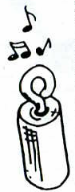
Material:
1 – 2 inch piece of close-grained hardwood, a dowel rod from the hardware store will do fine.
1 - “Chunky” eye-screw.
Directions:
- Drill a hole slightly smaller in diameter than the screw threads in the end of the block. Do not drill all the way through the block.
- Insert and turn the screw eye into it until it is tight.
- Unscrew the eye, put some powdered rosin into the hole (perhaps purchase a pitchers’ rosin bag at the sports store).
- Reinsert the screw eye
- As you twist the screw eye back and forth in the hole, very slowly, you will make a chirp-chirp or trill in loud, clear notes.
- If you wish, paint or decorate the bird call with marking pen designs or your own initials.
With practice, this simple devise will product an astounding variety of bird noises.
Plastic Straw Duck Call:
Sam Houston Area Council
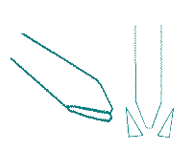
- Flatten a large plastic straw.
- Then trim one end of the straw as in the picture.
- This trimmed end is like a double-reed instrument mouthpiece.
- Hold the trimmed end firmly between your lips and blow very hard to make the plastic vibrate together.
- This will make a quacking noise like a duck.
Variations:
Plastic Straw Slide Whistle: To turn the duck call above into a slide whistle, cut off a third of the length of the straw at the untrimmed end. Now slice this small piece of straw along its entire length. Insert this straw into the open end of the duck call and you can now slide it in and out to make different notes.
Plastic Straw Flute: Modify the Duck Call above with several fingering holes along the straw, to make a flute. The easiest way to make the holes is to pinch the straw and use a paper punch to make a half-circle punch, which forms round holes.
Wood Duck House:
Thanks to Ducks Unlimited, Inc.
Sam Houston Area Council
Wood Ducks are an endangered species that can be found almost everywhere in the lower 48 states. They build nests near wetlands. Their nesting areas have special needs, and the houses are built with a door that rangers can use to clean the boxes each year after the nesting season is over.
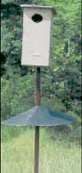
Materials:
10½ feet of 1x10 lumber (cedar is best).
Hand drill and assemble with wood screws.
Instructions:
- Drill five ½” drain holes in the floor, and cover with 4-6 inches of wood shavings (not sawdust!).
- Drill the entry hole as a 3½”x 4½” oval.
- Make horizontal cuts on the inside of the front piece (kerf cuts) so that ducklings can climb out.
- Install on a steel pole in or near water, with a clear flight path.
- Be sure to add a predator guard to the pole.
- Don’t leave any sharp edges or exposed screws on the inside of the box.
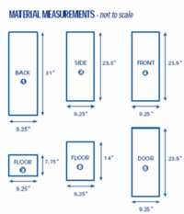
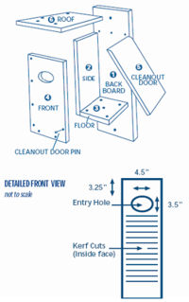
Nest Makings
Heart of America Council
Birds spend a lot of time in the spring and early summer looking for nesting material. You can help them out
Materials –
Net bag for each Cub. The kind onions come in are perfect. An alternative is to buy a piece of netting, cut a circle out of it for each boy, and have them run a piece of yarn around the outside of the circle.
Directions:
Fill the net bag with
- Pieces of yarn,
- String or twine of any kind,
- Shiny plastic "icicles" that are sold for Christmas trees
- Feathers,
- Or any other suitable material you think of
Once the nest materials are in the netting,
- Pull the yarn up tight and fasten, creating a small bag.
- Hang the bag from a tree branch in the spring
- Watch the birds make use of your offering.
Bird Feeder
Heart of America Council
Materials:
2 foil pie tins
1 juice can (or other tin can) with top removed
Twine or nylon cord
Tools: Hammer Large nail
Can/bottle opener
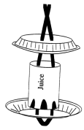
- Turn the can so it is top down.
- Center the pie tin on the can.
- Using a large nail and a hammer, punch two holes through the pie tin and the can bottom.
- Use a can opener to make openings along the bottom of the juice can. Fold these as flat as possible (or cut off).
- Punch two holes through the other pie tin, about two inches apart.
- Thread the cord through the first pie tin and the bottom of the juice can, then pull it through the second pie tin.
- Tie a knot, leaving about a foot of hanging space.
- To fill the feeder, pull aside the top pie tin and fill the can with birdseed.
- Replace the pie tin and hang the feeder.
Bird's Miracle Meal
Heart of America Council
Place in a large mixing bowl:
1 C. flour
3 C. yellow cornmeal Add:
2 C. melted suet (or lard, but not shortening or fat)
1 C. melted peanut butter
Optional - chopped raisins or nuts.
Mix well.
Chill the mixture until it is thick enough to handle.
Use one of the following options for putting it out for the birds to enjoy:
- Spread the mixture into pans until it is about 1" thick. Chill until hard, then cut into pieces. Place a piece inside a net bag such as oranges or onions come in, tie it closed and mount it against a tree trunk.
- Cut a 6 to 12" piece from a small log. Drill some shallow holes in the log and set a screw eye in the top. Press the soft mixture into the holes and hang the log from a tree branch.
- Force the soft mixture into existing holes or forks on a tree.
Leftover mixture will keep well in the freezer until you are ready to use it. This mixture will attract all the suet-eating birds - woodpeckers, chickadees, titmice.
Hang it up high enough, because the smell of the peanut butter will be attractive to your dog as well!
Berry Basket Bird Feeder
Heart of America Council
Materials:
2 plastic berry basket
2 slices of bread
Peanut butter mixed with shortening;
String
Birdseed
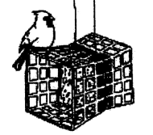
Directions:
Tie the baskets together, bottom to bottom.
Spread the peanut butter and shortening mixture on both sides of the bread.
Dip in birdseed.
Put a slice of bread into the bottom of each of the berry baskets.
Hang the baskets with the string.
Binocular Tie Slide
Materials:
1/2" dowel, 2 pieces 1" long
1/4" dowel, 2 pieces 3/8" long
1/8" dowel, 1 piece 5/8" long
Black pipe cleaner, 2 1/2" long
Paint (black, white or blue)
Wood glue, coping saw, sandpaper
Drill - 1/4" and 1/8" bits .
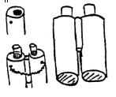
Directions
Cut dowels to length .
Drill 1/4" hole in one end of each 1/2" dowel, slightly off center, about 1/8" deep.
Drill a 1/8" hole (for pipe cleaner) on underside at the same end as 1/4" hole.
Glue 1/4" dowel in the end holes of the 1/2" dowel.
Lay the two 1/2" dowels side by side about 1/16" apart with the two end holes to center.
Glue 1/8" dowel in place, one end even with the top of the 1/2" dowels.
Sand and paint black with lens; end white or blue.
Glue pipe cleaner ends in the two small holes to form slide.
I think I would glue a piece of PVC pipe on the back for the slide loop. CD
Bird’s Nest Neckerchief Slide
San Gabriel Valley, Long Beach, Verdugo Hills Councils
Materials:
Brown Yarn
1 inch PVP pipe sliced at about ½ inch length or keychain ring
Tacky glue or low temp glue gun and glue stick
Poster board – dark brown or black
Crayola modeling clay - white
Scissors
Instructions:
- Cut poster board into circles about the size of a quarter.
- Cut yarn into ¼ inch pieces. For each bird nest you will need about 1 heaping tablespoon of cut up yarn.
- Mix in about ½ teaspoon of Tacky Glue with the yarn pieces. Roll yarn and glue mixture together to form a ball. Add more glue if necessary. Flatten the ball a little. Press thumb into the middle to make the nest shape. Set on top of a circle of poster board.
- Roll small pieces of Crayola modeling dough to make 3 small oval shaped eggs.
- Use glue gun to attach the eggs to the nests.
- Use hot glue gun to attach the back of the poster board to the pipe or ring.
Bird Feeder
San Gabriel Valley, Long Beach, Verdugo Hills Councils
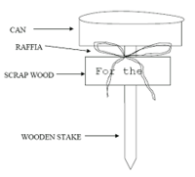
Materials:
Empty, clean tuna or cat food can
Wooden stake – 24” – 36” tall
Piece of scrap wood – rectangle shape about 3 by 10 inches
Raffia
Paint
Paint brush
Instructions:
- Nail the middle of the can to the top of the stake (the easiest way is to use a nail gun or staple gun)
- Use whittling knife to make a point on the other end of the stake.
- Paint the rectangle shape wood for a sign and paint the words “For the Birds” on the sign. For a longer more complicated project have the boys sand the wood before painting it.
- Nail or staple the sign to the stake
- Tie raffia around the stake above the sign
Cheerios Bird Feeder
San Gabriel Valley, Long Beach, Verdugo Hills Councils
Materials:
Big pipe cleaners
Cheerios
Instructions:
- Hook one end of pipe cleaner and add Cheerios until 1 inch from top.
- Bend pipe cleaner over Cheerios so they will stay on.
- Make the pipe cleaner with Cheerios look like a J.
- Hook over tree limb for birds to enjoy.
Plastic Jug Bird Feeder
San Gabriel Valley, Long Beach, Verdugo Hills Councils
Materials:
Large plastic jug such as a gallon milk container
Scissors
Twig
Bird seed or dry cereal
String
Instructions:
- Cut out a large section of the front of the jug with scissors
- Poke a hole on each side of the hole near the bottom of the jug
- Push a sturdy twig through the holes on each side for the birds to use as a perch
- Fill the bottom of the jug with bird seed or dry cereal.
- Tie a string to the neck of the jug and hang it in a tree
Easy Birdhouse to Make
San Gabriel Valley, Long Beach, Verdugo Hills Councils
Materials:
Empty paper half-gallon mild carton
Masking tape
Stapler
Brown Shoe Polish
Scissors
Sharp pencil
Wire coat hanger
Instructions:
- Get an empty paper half-gallon milk carton. Open up the top of the carton and wash and rinse it thoroughly. Let it dry.
- Re-close the milk carton and staple it shut.
- Get a roll of masking tape. Tear off 1-2" pieces of the tape and cover the entire milk carton. Overlap the pieces so that none of the carton shows.
- Get brown shoe polish and a paper towel or rag. Rub the polish over all of the tape to make it look like brown bark. Let dry thoroughly.
- Decide what type of bird you want to use the birdhouse. Look at the birdhouse specs page, and determine how large a hole to cut as well as how far from the floor the hole should be. Cut the entrance hole in the birdhouse.
- Using a pencil, make several holes in the bottom of the carton for any rain to drain out. Also make several hole in the top of the carton to let heat and condensation escape.
- Make a hole through the top of the house near the staples. Put a short piece of wire (perhaps from a clothes hanger?) through the hole to make a loop. Hang the birdhouse on a shepherd's hook (like what you use for birdfeeders) or on a tree branch.
Fruity Bird Feeder
San Gabriel Valley, Long Beach, Verdugo Hills Councils
Materials:
Grapefruit
Sharp knife
Metal spoon
Metal skewer
Yardstick
String
½ cup peanut butter
1 cup cornmeal
4 tablespoons raw sunflower seeds
4 tablespoons birdseed
Large bowl
Instructions:
- Carefully slice the grapefruit in half with a sharp knife, and scoop out the inside of one half with a metal spoon.
- Punch 3 evenly spaced holes with metal skewer around circumference of grapefruit shell, about ½ inch away from the cut edge
- Measure and cut three 20 inch pieces of string. Knot them together at one end.
- Put the knot under the grapefruit, and push one string through each hole working from the outside in. Tie ends of the string together in a knot at the top.
- Stir together the peanut butter, cornmeal, and seeds in a bowl. Fill the grapefruit shell with the mixture.
- Hang the bird feeder from a tree branch.
Cereal Loop Bird Feeder
San Gabriel Valley, Long Beach, Verdugo Hills Councils
Materials:
O shaped cereal
Yarn or string
Instructions:
- String O shaped cereal on lengths of yarn or string.
- Tie them like a necklace from a branch on a tree.
Fruit on a Stick
San Gabriel Valley, Long Beach, Verdugo Hills Councils
Materials:
Stick about 10 inches long
Apples or pears cut in half
String
Instructions;
- Cut the apple of pear in half
- Push the fruit half through the stick to the middle
- Tie string to each end of the stick
- Loop the string over a tree branch so the birds can perch on the stick while nibbling at the fruit.
North American Bird Feeding Chart
San Gabriel Valley, Long Beach, Verdugo Hills Councils
Use this chart to decide what to put in the bird feeders you make.
WILD BIRD SPECIES | PREFERRED FOOD | READILY EATEN
Quail, Pheasants | Cracked Corn | Millet, Berries
Pigeons, Doves | Millet | Sunflower, Milo, Bread, Nuts, Cracked Corn, Thistle
Roadrun-ners | Meat Scraps | Suet
Humm-ingbirds | Plant Nectar, Small Insects | Sugar Water, commercial instant nectars
Wood-peckers | Suet , Meat Scraps, Insects | Fruit, Nuts, Sunflower Seed , Sugar Water
Jays | Whole Peanuts, Peanut Kernels | Sunflower Seed, Suet, Bread Products, Cracked Corn
Crows, Magpies | Meat Scraps, Suet | Peanuts, Bread Products
Titmice, Chickadees | Peanut Kernels, Sunflower | Sunflower, Suet, Bread Products
Creepers, Nuthatches | Suet | Sunflower, Nuts, Cracked Corn, Bread
Wrens | Suet | Peanut Butter, Bread Products, Apples
Mocking-birds, Thrashers | Halved Apples, Fruit | Bread Products, Suet, Sunflower Seeds, Nuts
Robins, Bluebirds, Thrushes | Suet, Mealworms, Berries, Water | Bread Products, Raisins, Currants, Nut Meal
Purple Martins | Mosquitoes, beetles, flies, moths | Insects, man-made shelter and a water source is important
Flycatchers Phoebes | Bees, wasps & Ants | Meal Worms
Kinglets | Suet | Bread Products
Warblers | Suet, Suet Mix, Water |  | Fruit, Breads, Sugar Water Nut Pieces
Tanagers | Suet, Fruit |  | Sugar Water, Meal-worms, Bread Products
Cardinals, Grosbeaks, Buntings | Sunflower Seed, Safflower |  | Safflower, Apples, Fruits, Suet, Millet, Breads, Peanut Kernels
Towhees, Juncos | Millet, Sunflower Seed |  | Cracked Corn, Peanuts, Bread, Nut Meats
Sparrows | Millet, Peanut Kernels, Suet |  | Bread Crumbs, Canary Seed, Sunflower Seed
Blackbirds Starlings | Cracked Corn, Milo, Bread, Suet |  | Millet, Suet, Breads, Cracked Corn, Nut Meats
Orioles | Sugar Water, Fruit Pieces |  | Jelly, Suet, Soft Raisins, Orange Halves
Gold-finches, Finches | Thistle/Niger Seed, Sunflower |  | Hulled Sunflower, Millet, Fruits, Suet, Peanuts
Owls, Raptors | Small mammals, small lizards, snakes, birds |  | Water
Trash Can Lid Bird Bath
San Gabriel Valley, Long Beach, Verdugo Hills Councils
Materials:
Old trash can lid
Section of old sewer pipe
Brick or rock
Rope
Instructions:
- Fasten the brick to the lid of the trash can using the rope
- Place the lid upside down on the pipe with the brick inside. The brick should be hanging inside the pipe without touching the ground so it can provide weight to hold the lid down
- Add water
A birdbath can also be made by placing the trash can lid on the top of a tree stump.
Bird Bath:
San Gabriel Valley, Long Beach, Verdugo Hills Councils
Materials:
Wooden post – 48 inches long
2 by 2 piece of wood – 20 inches long for a cross bar
2 aluminum pie plates
2 screws
2 washers
paint
paint brushes
Instructions:
- Paint the aluminum plates so they are not shiny
- Screw the pie plates to either end of the 2 by 2 crossbar
- Nail the cross bar to the post so that plates are 24 to 36 inches above ground
- Fill one plate with water and one plate with bird seed
Nesting Supply Box for Birds
San Gabriel Valley, Long Beach, Verdugo Hills Councils
Materials:
Milk carton
String
Scissors
Dryer lint
Pet and people hair
Bits of yarn and string
Instructions:
- Cut a flap on opposite sides of the carton about halfway down
- wash the inside of the milk carton and allow to dry
- Fold the flaps of the milk carton down to create a perch for the birds to land on
- Thread a long piece of string through the openings. Tie the two pieces of string together with strong knots.
- Fill the box with the items collected (dryer lint, hair, string, yarn, etc.) that birds can use to make a nest.
- Hang the box outside in a tree.
Blue & Gold Banquet Ideas
See ideas in the Tiger section above.
Advancement opportunities using Blue and Gold Banquets Activities
- E9a Help with a party (Making decorations)
- E11f Sing a song at the banquet
- E2a-e Perform in a skit with costumes at the banquet
- E12d Make the background for a puppet show or skit
- E12f Make a poster advertising the banquet.
- E12a Freehand sketch for a poster, decorations, or place mats
- E12e Make a stencil, Use the pattern to make posters, invitations, or place mats. (Maybe make a Wolf track stencil.)
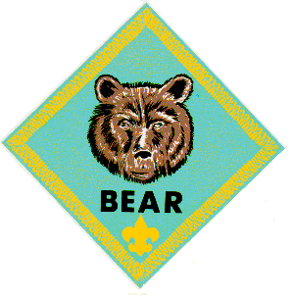

BEAR
Bears are working on Ach. #13, Ach. #15,
and Ach. #16, this month.
Meeting #9
DO: Ach. #16a Stretching; push-up, curl-ups, standing long jump; soft ball throw.
Ach. #16b Six two person contests.
Ach. #16c Relays: crab, gorilla, kangaroo. 30-yard dash.
Ach. #15b Play an organized game with your den.
HA: Ach. #13 Saving Well, Spending Well.
Sports E. #20d Track & field events works
well with den meeting #9
Physical Fitness belt loop/pin:
http://usscouts.org/advance/cubscout/sports/fitness.asp
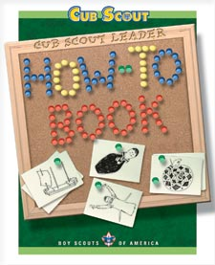 OR 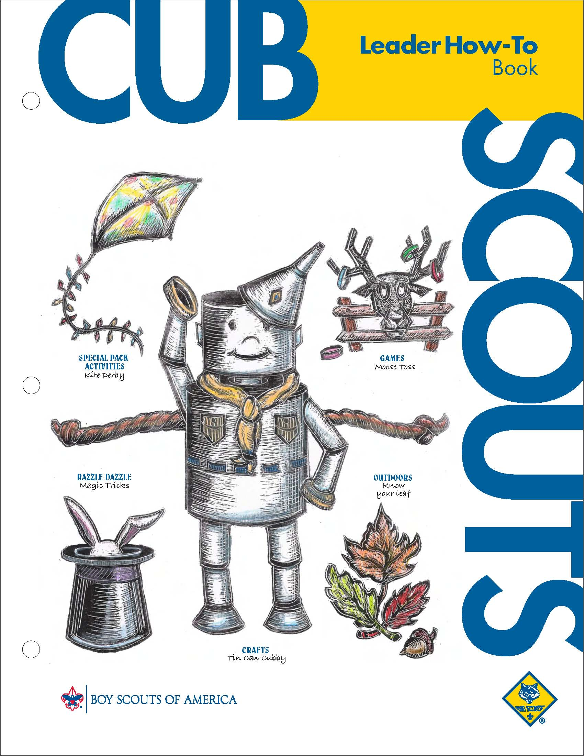
More 2 person games from the How To Book, p. 3—29-32: Arm Lock Wrestle, Broomstick Twist,
Broomstick Wrestle, Hand Push,
Hand Wrestle, Leg Wrestle,
Sparrow Sparring, Stork Wrestling.
Meeting #10
DO: Ach.#15a Set up and play a back yard game.
Ach.#15b Play two organized games with your den.
Ach. #15c Explain & play a game your den has not played before. Resource Guide recommends Ultimate.
HA: Ach. #6a Collect items at home for recycling.
Sports Belt Loops
- Ultimate belt loop & pin works well with den meeting #10: http://usscouts.org/advance/cubscout/sports/ultimate.asp
- Badminton Belt Loop/Pin: http://usscouts.org/advance/cubscout/sports/badminton.asp
- Badminton Belt Loop/Pin: http://usscouts.org/advance/cubscout/sports/badminton.asp
- Kickball Belt Loop/Pin: http://usscouts.org/advance/cubscout/sports/kickball.asp Volleyball Belt Loop & Pin: http://usscouts.org/advance/cubscout/sports/volleyball.asp
Money Ideas
See ideas in the Tiger Section above.
Ach. #13a
Field Trip Idea:
Alice, Golden Empire Council
Check with a local grocery store to see if your den can visit. They can learn a lot about how food gets to the shelf, why things are arranged the way they are, how prices are decided, what other services grocery stores provide – and why. They could also learn how to read labels and price tags, and how to decide which item is the best buy. I’ve done this with several dens, and even the parents who went along learned some new things!
Physical Fitness Ideas
Check out the physical fitness ideas from
the Wolf section in the Responsibility Baloo
Ach. #15b
Positive Reinforcement Game
Alice, Golden Empire Council
- One boy is sent out of the room where he can’t hear what the group is doing.
- The other boys decide on an action they want “It” to do when he returns.
- The first boy is called back into the room.
- Now, using Positive Attitude, the whole group claps to get “It” to do the right action.
- When he gets close to the right action, the group claps louder – if he is starting to do something that doesn’t fit the action, the group claps much softer.
- The goal of course, is to get “It” to do the right action – in a positive way!
Ach. #16a – Building Muscles:
Alice, Golden Empire Council
- Start out by practicing the basic physical fitness stretching exercises first.
- It would be great to have a “guest expert” come visit the den – either a fitness expert such as a trainer, a local athlete, or possibly a local sports coach. They could emphasize that every athlete has to start with stretching exercises – even if they have lots of natural talent. If you do this achievement during the winter months, consider having a local skiing coach or expert come in.
- The goal is to increase the confidence of each boy while he improves his abilities and strengthens himself physically. Be sure and give lots of positive encouragement.
Ach. #16b – Two-person contests
Alice, Golden Empire Council
These can be fun as long as you match the boys so they are as even as possible. You might divide up the den into two teams.
After they try all the different contests, let each boy choose his favorite – see if they can think of a funny name to describe each contest. They might even demonstrate their favorites at the pack meeting.
Ach. #16c – Walk with the Animals
Alice, Golden Empire Council
Try each of the animal relays – but for some extra fun, add animal sounds that fit each action.
Or turn this into a game: Prepare two sets of paper slips with the different actions on each one. One set of actions is in a bag at the starting line, the other set in a bag at the finish line. The first person on each team (or the leader) pulls a slip and the boy must do the action and act like the animal till he reaches the finish line. Then he must draw another slip and do that action back to the team, where the second team member is assigned an action. The winning team gets every member back first.
When the whole team is finished, the team members must Act like monkeys!
Take it up a notch – let the boys come up with some other animal walks – like a giraffe, a lion, a tortoise.
Backyard Games
Wendy, Chief Seattle Council
These games can be played indoors, or out
Jungle Mini-golf:
http://jas.familyfun.go.com/arts-and-crafts?page=CraftDisplay&craftid=10325
Portable Golf:
http://jas.familyfun.go.com/arts-and-crafts?page=CraftDisplay&craftid=11745
- Golf Holes: A milk jug holds its shape better than a pop bottle.
- Golf Club: Roll up a piece of cardboard 6 inches by 3 feet, and tape. Fold a 3- by 11-1/2-inch piece of cardboard around the bottom the cardboard handle. Wrap duct tape around the two pieces to secure them together, then wrap the rest of the tube.
- Golf Ball: crumple aluminum foil into ball. If desired, use an upside-down egg cup from an egg carton as the tee.
Balloon Badminton: (Bear Ach. #15a, Ach. #23b,c)
- Cut a piece of corrugated cardboard into a rectangle 6 inches by 1 ½ feet, making sure the ribs of the cardboard run the long way.
- Roll up the cardboard width wise to create the 1 ½ foot long handle for the racquet.
- Duct tape, hot glue, or tacky glue the edge of the cardboard. (You may need to use rubber bands to keep the cardboard from unrolling while the glue dries.)
- Decorate a paper plate.
- Tacky glue the decorated plate to a second paper plate, with the decorated plate on top.
- Using a nail, punch holes in the paper plate, and enlarge the holes with a pencil. (The holes reduce wind drag.)
- Tacky glue the plates to the cardboard handle.
- Tie a string to 2 trees, a little above the boys’ heads for a net. (Or have 2 leaders hold the string.)
- Use a balloon for the shuttlecock.
- The boys play badminton, batting the balloon back and forth over the string.
Backyard Golf:
http://www.scouting.org/filestore/pdf/2008-08.pdf
’07-’08 Program Helps August p. 10.
Balloon Volleyball:
Boys bat balloon (or beach ball) instead of volleyball over string (net).
Mini Games (good for gathering games)
Wendy, Chief Seattle Council
Tabletop Golf:
Set Up:
Draw Golf course on paper, 4 holes on one side, and 5 holes on the other. Vary the size and shape of the putting greens. (Some with a 90 degree curve, some wiggly like a snake, some pear shaped, etc.) Add water and sand hazards. Trace around a nickel to make the holes. Color the golf course, and slide papers into a protective plastic sleeve.
Rules:
Using a pencil (or golf club made from a craft stick), hit the golf ball (dime) into each hole using as few strokes as possible. (Players can color their dime with washable marker so they can tell the dimes apart.)
The dime is out of bounds or in the hole if more than half the dime is over the line.
Add penalty strokes for the following:
Water: 2 strokes.
Sand: 3 strokes.
Another hole/off the green: 4 strokes.
The player with the fewest strokes wins. (Variation on game from the Dollar Store.)
Tabletop Shuffleboard: http://en.wikipedia.org/wiki/Shuffleboard
Draw shuffleboard court on paper, and slide into a plastic protective sleeve. Color 4 dimes one color with washable markers, and leave the other 4 dimes plain. Players push the dimes toward the shuffleboard court with a pencil. Score points if the dime is completely within the scoring compartment. Player with the highest score wins. (Variation on game I saw in a Dollar Store.)
Really Mini Miniature Golf:
Golf Club:
Using pruning shears, cut 1” off the end of a craft stick. Sand both ends smooth. Tacky glue the small piece to the cut end of big piece at slightly more than a 90 degree angle to make a golf club.
Holes:
Cut a strip of paper about one inch wide by 4 inches long. Overlap the ends, and tape, creating a circle. Pinch the loop in two places, creating a flat side about 1 inch in length. Place the hoop on the flat side so it stands up. Make 9 of these hoops, and number them. Place them on the floor.
Create obstacles using cups and toilet paper tubes. Make ramps from cardboard. Bounce marbles off books.
The Play
Players hit marbles through the hoops with their craft stick golf clubs, trying to hit the ball into the hole with the fewest strokes. The player with the lowest score wins.

WEBELOS DENS

Joe Trovato,
WEBELOS RT Break Out Coordinator
Westchester-Putnam Council
Have a question or comment for Joe??
Write him at
webelos_willie@yahoo.com
There is an underscore between Webelos and Willie

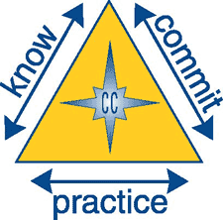

Core Value:
Positive Attitude

Positive Attitude: Being cheerful and setting our minds to look for and find the best in all situations.
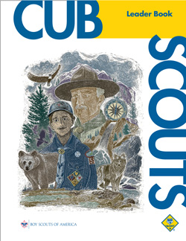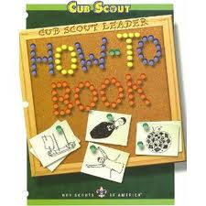
Chapter 4 of the Cub Scout Leader Book is a great resource on Character Connections. Chapter 3 is dedicated to helping you make the scout's experience positive.
Some Practical Applications:
- Be positive in your thoughts and words.
- Be cheerful. Look for the bright side of all situations.
- Keep a good sense of humor.
- Be optimistic.
- Think good thoughts.
- Believe in yourself.
- Trust your friends, family, and teammates.
In addition the Cub Scout Leader How-To Book addresses “Boy Behavior” in Chapter 1, pages 12-14, and stresses the need for leaders to “Accentuate the Positive” with recommended activities.
Meeting Planner
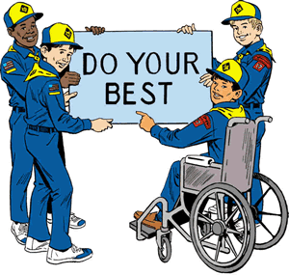
In tune with this month’s core value of Positive Attitude, consider how you can make each activity positive and use each as a learning experience for the scout. The Cub Scout Leader Book provides a three step process for incorporating character development in each activity:
“Leaders can emphasize more values and make more character connections as boys participate in the many activities they enjoy in Scouting. You can connect values while going on a hike, cooking an outdoor meal, or working on a project very easily, using this three-step method:
1. Plan it.
2. Do it.
3. Review it.”
See page 23 for additional information.
Flag Ceremony

This month’s ceremony may focus on Dr. Martin Luther King, Jr., whose life we celebrate with a national holiday on January, 2011. A standard opening ceremony may be used. After having the Pack or Webelos den recite the Pledge of Allegiance and Cub scout Promise (at Pack Meeting) or Boy Scout Law (at Webelos meeting), have the Denner read an inspirational quotation from many left to us by Dr. King or provide a short tribute to the man. Portions of the “I have a dream” speech (or the whole thing, if the scouts are well behaved) can work. Similarly, mention Dr. King when retiring the flag at the end of the meeting.
OPENING COLORS AT PACK MEETING
Audience, Please Rise!
Color Guard, Forward March!
Scout Salute! Those not in uniform, please place your right hand over your heart. (**say this right away, as the audience will salute the flag as it’s being marched forward**)
(>>wait for color guard to reach the front<<)
Color Guard, Halt!
Color Guard, Cross the Colors!
(>>wait for flag bearers to move to the flag pole stands<<)
Color Guard, Post the Flag of the United States of America!
Color Guard, Post the Flag of the Great State of [your state name]!
Color Guard, Proudly Post the Flag of [your town name]’s Pack ###!
Color Guard, Honor your Colors! (**Flag bearers salute the US flag**)
Please recite the Pledge of Allegiance:
I pledge allegiance - to the Flag - of the United States of America -
And to the Republic - for which it stands -
One Nation - Under God – Indivisible - and with Liberty and Justice for All
TWO! (**Everyone drops salute**)
Cub Scout Sign! (**Everyone raises right hand making the Cub Scout sign**)
Please join us in saying the Cub Scout Promise:
I, ........, promise to do my best,
to do my duty to God and my country,
To help other people,
and To obey the law of the Pack.
TWO! (**Everyone drops Cub Scout sign**)
Today we honor Dr. Martin Luther King, Jr., a leader of the non-violent Civil Rights Movement in the U.S. He not only began the Civil Rights Movement, he himself became an icon for the entire movement. Martin Luther King Day is a federal holiday observed on the third Monday in January. Congress passed the holiday legislation in 1983, which was then signed into law by President Ronald Regan. Perhaps his most famous speech was the “I Have A Dream” speech, given on the steps of the Lincoln Memorial on August 28, 1963. He said:
"I say to you today, my friends, that in spite of the difficulties and frustrations of the moment, I still have a dream. It is a dream deeply rooted in the American dream.
"I have a dream that one day this nation will rise up and live out the true meaning of its creed: "We hold these truths to be self-evident: that all men are created equal."
"I have a dream that my four children will one day live in a nation where they will not be judged by the color of their skin but by the content of their character.
"I have a dream today.
"I have a dream that one day ... little black boys and black girls will be able to join hands with little white boys and white girls and walk together as sisters and brothers.
"I have a dream today"
Color Guard, return to ranks.
(>>wait for flag bearers return to formation<<)
Color Guard, About Face! (**Color guard turns around to head back**)
Color Guard, Forward March!
(>>wait until color guard reaches back of room<<)
Color Guard, Halt!
Color Guard, At Ease!
Audience, Please be seated.

Den Activities
These activities supplement the Den Meeting plans in the Den and Pack Meeting Resource Guide and on-line at www.scouting.org/cubscouts . They can be used for the gathering or to reinforce/satisfy badge requirements.

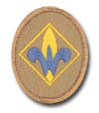

WEBELOS RANK
Wendy, Chief Seattle Council
Meeting #9
DO: Geologist #1 Collect 5 specimens
Geologist #2 Give examples of minerals that are used in metals, glass, jewelry, roads, fertilizer.
Geologist #8 Geology field trip.
Meeting #10
DO: Geologist #4 List some geologic materials used in building a house
Geologist #5 Volcano, earthquake, or geyser drawing
Geologist #6 Explain one way mountains are formed
Geologist #8 Field trip discussion.
HA: Review engineer chapter
Geology Belt Loop/Pin:
http://usscouts.org/advance/cubscout/academics/geology.asp
For more games & crafts, go to:
2009 “Jurassic Park” theme
Baloo's Bugle
http://usscouts.org/usscouts/bbugle/bb0903.pdf
or
http://www.scoutingthenet.com/scouting/Training/Roundtable/Handouts/09/03/
2006 “Diggin’ in the Dirt” theme
Baloo's Bugle
http://usscouts.org/usscouts/bbugle/bb0604.pdf
or
http://www.scoutingthenet.com/scouting/Training/Roundtable/Handouts/06/04/
2004 “Cub Rock” theme
Baloo's Bugle
http://usscouts.org/usscouts/bbugle/bb0405.pdf
or
http://www.scoutingthenet.com/scouting/Training/Roundtable/Handouts/04/05/

Geologist
Joe Trovato,
WEBELOS RT Break Out Coordinator
Westchester-Putnam Council
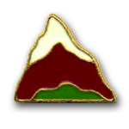
This month first year Webelos will be working on the Geologist activity badge. These activities supplement the Den Meeting plans available at scouting.org and linked to below. They can be used for the gathering or to reinforce/satisfy badge requirements.
Meeting 9: Geologist
Do: Geologist 1, 2, 8
HA: Review Geologist chapter.
Meeting 10 Geologist
Do: Geologist 4, 5, 6
HA: Review Engineer chapter.
One thing to consider is whether you can bring your scouts to a nature sanctuary that may provide some or all of the hands-on activities that your scouts may need to complete the Geologist activity badge. One example in Westchester-Putnam Council is the Westmoreland Sanctuary in Mount Kisco, New York.
They have adapted their geology program to meet the requirements of the Geology activity badge. here is a description of what they offer:
Geology / Earth Science
60-75 min.
Rocks and minerals provide many of the materials we use or have around us every day. Scouts will learn about many of the common materials that come from or are derived from rocks and minerals. We will also discuss the layers of the earth, how rocks form and their classification, and how movement of the earth’s crust leads to earthquakes, volcanoes, and mountain formation. All topics are emphasized with the use of illustrations, models, and geologic specimens from our collection. (adapted for Webelos Geologist Badge)
Basic Rock Collecting Tools
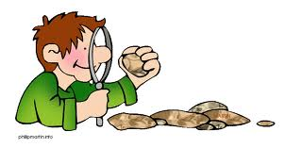
The basic tools that any geologist, rock collector or fossil collector needs are:
* Rock lens
* Rock hammer
* Compass
* Geologic maps
* Rock and mineral guide
* Field notebook
* Geology notebook pouch
A rock lens is useful for looking at minerals and fossils that are too small to see with the naked eye. Rock lenses can range in magnifying power from 7X to 20X - the most commonly used rock lenses have a magnification of 10X. They are small enough to fit in your pocket, although many geologists hang them around their neck with a lanyard or cord for quick and easy access.
The Rock Cycle
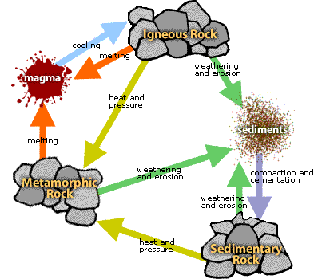
Rocks are the most common material on Earth. They are naturally occurring aggregates of one or more minerals.
Rock divisions occur in three major families based on how they formed: igneous, sedimentary, and metamorphic. Each group contains a collection of rock types that differ from each other on the basis of the size, shape, and arrangement of mineral grains.
The rock cycle is an illustration that is used to explain how the three rock types are related to each other and how Earth processes change a rock from one type to another through geologic time. Plate tectonic movement is responsible for the recycling of rock materials and is the driving force of the rock cycle
Inside the Earth
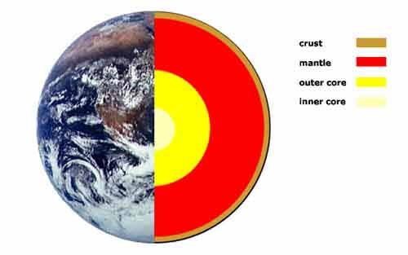
The Crust - silicate rocks, primarily granite and basalt
- Oceanic Crust - mostly basalt
- Continental Crust - igneous, metamorphic, and sedimentary rocks
The Mantle - iron and magnesium rich silicate rocks
- Upper Mantle
- Lower mantle
The Core - iron nickel alloy
- Outer core
- Inner core
Make a Model Glacier
from windows2universe.org

This will require lots of preparation and may be dome over a few meetings. The scouts love it and it is real science!
MATERIALS AND WORKSHEETS:
Ingredients to make the glacier model material (known as flubber)
* Two containers for mixing
* ¾ cup warm water
* 1 cup white glue
* ½ cup warm water
* 2 teaspoons Borax
Each group will need:
* Large diameter PVC pipes about two feet long, that have been cut lengthwise
* Cardboard boxes or books (to prop up PVC at one end making a slope)
* Ruler
* Permanent marker
* A watch or stopwatch
For part 2 of the activity, scouts may need some of the following for their experiment:
* Sandpaper
* Vegetable oil
* Water
* Protractor
* Hot water bottles with boiling water and ice water (or a refrigerator)
DIRECTIONS:
Preparation
- Combine ¾ cup warm water, 1 cup of white glue in a container and mix.
- In a different container, combine ½ cup warm water and 2 teaspoons of Borax and mix thoroughly.
- Pour the Borax mixture into the glue mixture. Mix all ingredients with hands. You will need to lift and turn the mixture to incorporate as much of the liquid as possible.
- Let the excess liquid drip off and the flubber will be ready for your glacier models.
- Notes:
- The flubber can be reused and will keep for several weeks in an airtight container.
- Safety: White glue is typically non-toxic, but check the packaging of the type you are using to confirm. Borax is harmful if swallowed and the dust from the dry borax can be irritating if inhaled. Ensure scouts wash their hands with soap and water after using it.
During this part of the activity, scouts are introduced to the glacier model.
- Provide each student group (3-4 scouts) with a piece of flubber, a PVC tube that is cut in half to simulate a valley, and a ruler.
- Allow scouts to hold and play with the flubber to get it know its properties. Explain that Flubber is a polymer that has the properties of both a liquid and a solid. The molecules in the flubber are loosely arranged and can slide past each other. Explain that scouts will use the flubber to simulate glacier ice.
- Have groups stack books or boxes under one end of the PVC to make a slope for the valley.
Instruct scouts to put the flubber at the high end, patting it down to fill the top of the valley. You may wish to have scouts draw a line across the flubber with a marker to see which part of a valley glacier moves the fastest.
- Have scouts monitor the flubber as it moves down the simulated valley, measuring how far it travels with a ruler.
- Discuss how this model is like a glacier in a valley and how it is not like a glacier in a valley. Remind scouts that no model is perfect.
- Brainstorm questions about how glaciers move. What conditions cause glaciers to move faster? Slower?
Temperature: All ice is cold, but if the ice in one glacier is colder than the ice in another, will that affect how fast the glacier moves?
Slope: Does a glacier in a steep valley move faster than a glacier in a less steep valley?
Valley texture: Since glaciers move in part by sliding on their base (a process called basal slip), does the texture of the surface they are slipping on make a difference in the rate of movement? Also, there is evidence that melt water might lubricate the base of the glacier causing it to move faster.
Experiment
Divide the scouts into three groups so each will do one of the following experiments:
- To test for differences in temperature: one piece of flubber can be cooled by putting it on a water bottle filled with ice water, while the other is warmed by putting it on a hot water bottle before allowing the glaciers to slide down the valleys.
- To test for differences in valley slope: the two PVC valleys can be put at different angles and the angle of each slope measured with a protractor.
- To test for differences in texture of the valley: sandpaper can be used to line the valley to add texture. Oil or water can be used on the valley surface to make it slippery.
Have a student in each group serve as timekeeper during the experiment and record how far each flubber glacier advances each minute. If time permits, have scouts repeat the experiment a number of times to see if the results are always similar.
Come to a conclusion as to which of the three variables caused the “glacier” to move quicker.
You can find more Geology activities in past Baloo's Bugles:
http://www.usscouts.org/bbugle/bb0906.pdf
http://usscouts.org/bbugle/bb1006.pdf
http://usscouts.org/bbugle/bb0806.pdf
Fossil Excavation Activity:
Wendy, Chief Seattle Council
Bury the pieces of a wooden dinosaur puzzle in a bucket or box of sand. The boys must excavate the pieces of the “fossil.” and assemble it.
Fun With Crystals
Alice, Golden Empire Council

Materials:
A piece of black construction paper for each boy.
Salt
Sugar
Chocolate Chip Cookies
Magnifying glass – one for each boy or team
Instructions:
See if the boys know what crystals are – you might even look it up in a dictionary.
Give each boy a piece of black paper and a few grains of salt.
Each boy can look at the salt with the magnifying glass – what shape are the crystals?
(They should look like cubes)
Now give each boy a few grains of sugar, and repeat the process. The shape of these crystals is harder to identify, but they have more angles and points – and they are definitely NOT cubes.
You might challenge the boys to find out what the seven basic crystal shapes are – or to find out some other crystals that we use every day.
Rock candy would be fun to look at and eat!
But if you want to demonstrate how minerals are taken out of the earth, give each boy a chocolate chip cookie and some “tools” to mine the chocolate chips out of the ground – could be as simple as some toothpicks.
After each boy gets a chocolate chip out of the cookie, ask him to see if it will fit back into the hole it came from and look the same. Of course, it won’t – and this is what happens when minerals are mined from the earth – sometimes whole mountain tops are removed!
Check online or in a National Geographic for some graphic photos of how mining for minerals can change the landscape.
Metamorphic Rock Pancakes
Alice, Golden Empire Council
A fun way to demonstrate metamorphic rocks – by Paul Perkinz, Em Shipley and Stephany Pitts.
You will need:
- Griddle or frying pan, lightly oiled
- Spatula
- Pancake batter
- Assorted foods, some which melt and some that don't (examples: raisins, coconut, marshmallows, nuts, chocolate chips, etc.)
- Plates, napkins, and utensils.
NOTE: Caution Cubs about hot surfaces
and/or open flames during this activity.
Instructions:
- Mix the pancake batter and add the assorted foods into the mixed batter. Mix gently to distribute the foods.
- Pour a smaller than normal pool of batter into the heated pan.
- After the batter is about half solid, press down with the spatula to exert pressure onto the pancake. The idea is to change the shape (by pressure) of those ingredients the heat hasn't changed. Turn the pancake over and repeat the process until done.
Since Cub Scouts will eat almost anything, Metamorphic Rock Pancakes (with whatever is inside them) should be a treat at a Den Meeting. For Webelos working on Geologist (or even Scientist), this would be extra fun to do the activity requirements. Explain to the Webelos how heat and pressure combine to create rocks, a process much like the pancakes they just made.
Another found by Paul Perkinz, Em Shipley and Stephany Pitts, Three Rivers Council the Buffalo District Staff is at: http://www.makestuff.com/foodstuff/octopus.html and is shown as being contributed by T. Roe
Edible Volcano
Alice, Golden Empire Council
Ingredients:
Pointed ice cream cones, with the pointed end cut off;
Bowls of prepared chocolate pudding; red, yellow and orange frosting in squeeze bottles (or ready made squeeze bottles of frosting);
gummy dinosaurs
Directions:
Have each boy drizzle the frosting down the ice cream cone, starting at the cut end, to make the erupting volcano.
Give each boy a bowl of chocolate pudding.
Ice cream cone is set down into the pudding to make the volcano, and gummy dinosaurs can be set into the pudding.
Field Trip Ideas:
- Visit a local rock and mineral show.
- Check with your librarian to find a local club of rock hounds – ask one of them to visit your den and share their expertise.
- Check with local colleges, universities, or nature centers – they often have a department of geology, or even a site that can be visited.
Online Help:
- Check out the ideas and activities at: www.kidsgeo.com/geology-for-kids/

ARROW OF LIGHT

The Arrow of Light Den Meeting Planner for Meeting 9 and Meeting 10 call for Webelos Den leaders to confirm completion of the Readyman requirements worked on last month (requirements 4-7) and making sure to complete requirement 8. Also this month, Webelos leaders should be helping their scouts complete their Arrow of Light requirements.
Looking back to the Webelos-to-Scout transition schedule in last October's Baloo's Bugle, your scouts should have visited at least two Boy Scout troops, joined a troop for an outdoor activity, and decided on a troop to join. If you haven't gone on an overnight or day hike check out state or county parks in your area that have trails , or better yet, have guides that can help the scouts appreciate the natural beauty as they hike the trail. Some parks are built around historic sites, which give an added element to completing this requirement. Requirements 2 and 7 should be confirmed and any outstanding requirements completed.
2. Show your knowledge of the requirements to become a Boy Scout by doing all of these:
- Repeat from memory and explain in your own words the Scout Oath or Promise and the 12 points of the Scout Law. Tell how you have practiced them in your everyday life.
- Give and explain the Scout motto, slogan, sign, salute, and handshake.
- Understand the significance of the First Class Scout badge.
- Describe its parts and tell what each stands for.
- T ell how a Boy Scout uniform is different from a Webelos Scout uniform.
- Tie the joining knot (square knot).
7. Complete the Honesty Character Connection.
- Know: Say the Cub Scout Promise to your family. Discuss these questions with them: What is a promise? What does it mean to keep your word? What does it mean to be trustworthy? What does honesty mean?
- Commit: Discuss these questions with your family. Why is a promise important? Why is it important for people to trust you when you give your word? When might it be difficult to be truthful? List examples.
- Practice: Discuss with a family member why it is important to be trustworthy and honest. How can you do your best to be honest even when it is difficult?

8. Tell what steps must be taken for a safe swim with your Webelos den, pack, family, or other group. Explain the reasons for the buddy system. Also see past Baloo's Bugles for safe swim information as well as the Guide to Safe Scouting on-line and Chapter 12 of the Cub Scout Leader Book.
Honesty Character Connection
The Dolphin and the Monkey
(an Aesop fable)
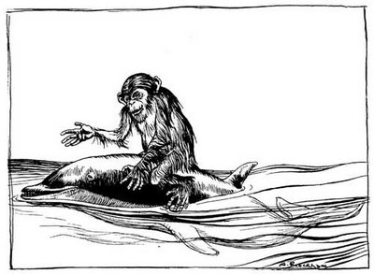
A monkey was traveling by ship from one country to the next. One day he climbed the mast of the ship to get a better view. Unfortunately, as he was looking at the ocean, a big wave crashed into the boat and the monkey was thrown into the water. He frantically called for help, but no one on the boat heard him yelling.
The boat sailed on. A dolphin, seeing his predicament, swam underneath the monkey, lifted him onto his back and swam toward land.
The monkey began to talk to the dolphin about how important he was. “Everyone on this island knows me. In fact, the king of this island is one of my closest friends. I am sure to have a fine welcome when I get to shore.”
The dolphin listened politely, and looked wonderingly at the shore of the island. There were no animals, no people, no houses or palaces and not even a wisp of smoke to be seen. He placed the monkey on the shore, and then swam quietly away, leaving the boastful monkey to himself.
Moral:
Your lies will always be discovered.
Why Lincoln Was Called
"Honest Abe"
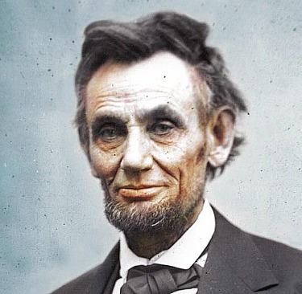
Noah Brooks, Abraham Lincoln
In managing the country store, as in everything that he undertook for others, Lincoln did his very best. He was honest, civil, ready to do anything that should encourage customers to come to the place, full of pleasantries, patient, and alert.
On one occasion, finding late at night, when he counted over his cash, that he had taken a few cents from a customer more than was due, he closed the store, and walked a long distance to make good the deficiency.
At another time, discovering on the scales in the morning a weight with which he had weighed out a package of tea for a woman the night before, he saw that he had given her too little for her money. He weighed out what was due, and carried it to her, much to the surprise of the woman, who had not known that she was short in the amount of her purchase.
Innumerable incidents of this sort are related of Lincoln, and we should not have space to tell of the alertness with which he sprang to protect defenseless women from insult, or feeble children from tyranny - for in the rude community in which he lived, the rights of the defenseless were not always respected as they should have been. There were bullies then, as now.

Readyman
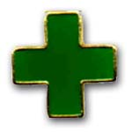
Readyman is required for the Arrow of Light. What is a Readyman. Simply said, someone who is always ready to do whatever is needed to help someone or himself. Similar to the Boy Scout who follows the motto, “Be Prepared,” a Webelos Readyman knows his stuff and is not afraid to help.
Meeting #9
DO: Readyman #2 First aid definition
Readyman #4 Heimlich maneuver
Readyman #5 Dealing with “hurry” cases
Readyman #6 Treating shock
Readyman #7 Treating assorted ailments
Readyman #8 Safe swimming
Readyman #13 Home accidents
HA: Review Arrow of Light requirements


Arrow of Light Requirements
Meeting #10
DO: Decorate career arrows.
HA: Review handyman requirements.
Start on requirement #1.
Readyman
Banged Up Benny
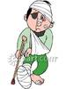
Required:
- Neckerchiefs.
- Folded up paper towels to use as sterile pads.
- List of wounds on paper for each group.
Instructions:
Split in groups of 4 to 6 scouts.
One scout is Benny, he's all banged up from some terrible accident; the rest are rescuers.
Scouts line up single file with Benny out in front of them 10-30 feet. Have first aid materials beside each Benny.
On the leader's go signal, the first rescuer sees Benny, runs to him, and asks what is wrong. Possible injuries are: scalp wound (head bandage), thigh cut (pressure wrap), sprained ankle, broken arm (sling), hand or wrist cut (pressure pad).
Rescuer applies his neckerchief and sterile pads as required where indicated.
When complete, he asks Benny if there's anything else wrong. If Benny says "Yes", the rescuer calls for help.
The next rescuer takes a turn helping Benny and then asks if there is more.
When Benny says "broken legs", the scout needs to get help and two scouts carry him back in a four-hand seat carry with the other scouts spotting.
This is used for serious practice in a fun way and there should be no time limit - try to have the scouts make good application of the dressings.
Pressure Pad Relay
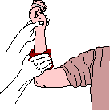
Equipment - Each boy using his own neckerchief
Instructions:
One boy is about 30 feet in front of the team with arterial "bleeding' of the left wrist. There is one judge for each victim.
On signal, the first boy from each team runs up and applies a pressure pad over the simulated would.
When correct, the judge yells "off,” the boy removes the pad and runs back to the team, tags off the next boy who repeats the operation
Heimlich Maneuver on an Adult
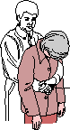
If the person is sitting or standing, stand behind him or her. Form a fist with one hand and place your fist, thumb side in, just below the person’s rib cage in the front. Grab your fist with your other hand. Keeping your arms off the person’s rib cage, give four quick inward and upward thrusts. You may have to repeat this several times until the obstructing object is coughed out.
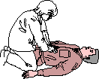
If the person is lying down or unconscious, straddle him or her and place the heel of your hand just above the waistline. Place your other hand on top of this hand. Keeping your elbows straight,give four quick upward thrusts. You may have to repeat this procedure several times until the obstructing object is coughed out.
How to Stop a Nosebleed
Firmly pinch the entire soft part of the nose just above the nostrils.
Sit and lean forward (this will ensure that blood and other secretions do not go down your throat).
Breathe through your mouth.
Hold this position for 5 minutes. If bleeding continues, hold the position for an additional 10 minutes. If bleeding does not stop, go to the nearest hospital emergency department
What Should I Do?
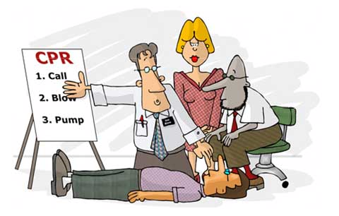
This game is a fun way to practice the skills the boys will learn.
Write emergency conditions on cards. A Scout draws a card and then must demonstrate or explain the appropriate actions. The Heimlich maneuver, rescue breathing, and CPR should be explained.
Have a phone (disconnected of course) and first aid kit available.
More Readyman Ideas:
Alice, Golden Empire Council
- Ask a “guest expert” to help – a parent with some medical training, or from a local medical group – check with Venturing Scouts in your area!
- Use the EDGE method to demonstrate how to do the requirements in Readyman #5 - #7
- After each boy has had a chance to practice and learn each skill, you can have a fun competition:
Are You Ready?
Alice, Golden Empire Council
- Make up scenarios that use each of the first aid actions listed in the above Readyman requiremets.
- Divide the den into two teams.
- Make sure the necessary items are available for each team – emergency “splints” for example.
- Read off the first scenario – each team must take care of the “emergency situation” in the right way – but keep it fun!

ADDITIONAL ADVANCEMENT IDEAS
Alice, Golden Empire Council
Someone wrote and asked me why Alice and I have this section with all the advancement in the new Resource Book. These are additional ideas. Maybe your Cubs did some advancement in camp and you got to skip a section. Maybe your den is above average and streaking through the program. Maybe you want some ideas to tie into the Core Value of the month. Maybe your presenter or field trip for that week fell through and you need a Plan B. Here are ideas you can use!! CD and Alice
Alice, Golden Empire Council
All the ideas in this section are based on the assigned Value for January 2011 – Positive Attitude! Cub Scouts can focus on having a Positive Attitude this month as they learn new skills or tackle new challenges. They can also share their skills and interests at the Pack meeting – and any requirement for any rank that covers a special interest of a boy could be included. Belt Loops and Pins can serve as a starting point for setting goals. Parents and Den Leaders can help scouts by teaching how to work step by step on learning or improving a skill.

Tiger Achievements
Ach. # 1D – Make a family scrapbook – looking back at past activities is a POSITIVE experience. Ach. #1G – When visiting a museum, library, or historical building, look for examples of Positive Attitude in action.
Ach. #3Fa and Fb – Discussing and practicing what to do in an emergency or when lost helps build confidence that you will KNOW what to do. Even if you have already done these activities, review them from time to time – you could even make a game of it!
Ach. #4F – Continue to practice family conversation and good manners at family meals. Remember the story of Mansay! Ach. #4G – Visit a TV or Radio station or Newspaper office – find out how people there communicate to each other (and ask if they have any special ways of sharing “Good News” or positive stories)

Tiger Electives
Elect. #1 – Celebrations are a way to share Positive Attitude – Have each boy share an example from his family or experience.
Elect. #2 – Make some decorations – boys could work on decorations for the Pinewood Derby, or make special awards for parents and others who have helped the den.
Elect. #6 – With your adult partner, teach a song to your family or den and sign it together – try a “Positive Attitude” song like the one on pg. 87 – or one from this month’s Baloo.
Elect. #7 – Make a musical instrument and play it with others to demonstrate Positive Attitude.
Elect. #9 – Share your Positive Attitude by making a new friend.
Elect. #13 – Learn to make change accurately – you can do it! Now visit a bank - Elect. #50 – to learn how money is kept safe.
Elect. #14 – With your adult partner, read about someone who demonstrates Positive Attitude, like an athlete or someone who has had to overcome a challenge
Elect. #16 – Show or tell your den about a collection or favorite hobby or interest
Elect. #17 – Make a Pinewood Derby car or other model
Elect. #18 – Learn how to sew on a button – you might also be able to sew patches on your vest with some help from your adult partner!
Elect. #19, #21 – Learn how to perform a magic trick or make a puppet – remember to keep a Positive Attitude that you can do it.
Elect. #27 – Talk about what to do in an emergency so you will feel confident you know what to do

Wolf Achievements
Ach. #1 – Keep a Positive Attitude if you need more practice to do some of the Feats of Skill;
Ach. #2g – Practice with a positive attitude to perfect folding the flag.
Ach. #5 – Keep a positive attitude as you practice skills so you can use tools to make a wood project.
Ach. #6a – Complete the Character Connection for Positive Attitude; Ach. #6b,c – Make a collection and share it with another person.
Ach. #9b, c,d, e – Know how to make your home and yourself safe and you will be more confident
Ach. #10d, e – Read a book or Boy’s Life article or watch a TV show about someone who showed Positive Attitude – share what you learned

Wolf Electives
Elect. #3 – Do these requirements while you are working with tools on Ach. #5 – the more you learn and practice, the more confident you will be using tools
Elect. #5g,h,i – Make a Pinewood Derby Racer
Elect. #6b – Choose a book about Positive Attitude or someone with that quality – ask the librarian if you need help!
Elect. #7c – Make a pair of foot racers using tools for Ach. #5e.
Elect. #11c, f – Learn and sing Cub Scout songs – choose one about Positive Attitude, such as Cub Scout Spirit on pg. 164
Elect. #16 – Talk with your family and learn what to do in case of an emergency, so you can feel confident; take the positive step of listing what should be in a first aid kit and knowing where your family kit is kept.
Elect. #20b, d, e – Know and practice the safety rules for boating or winter sports.
Elect. #22c, d, e – Tell a short story to your den – look for one that shows Positive Attitude; Demonstrate that you know how to get to nearby police and fire stations and other important places; Demonstrate Positive Attitude by helping a boy join scouting or complete his Bobcat.
Elect. #23b,c,d – Learn how to take care of yourself in the outdoors, if you get lost, and how to use the buddy system – you can feel more confident if you know what to do!

Bear Achievements
Ach. #3b – With the help of a parent of den leader, find out about two famous Americans who have had a Positive impact.
Ach. #6a,b – Demonstrate Positive Attitude and the power of one person by doing recycling in your home or planting a tree.
Ach. #8c, d, f – Start or add to a den or pack scrapbook so others can look back on positive experiences; Trace your family geneology and talk to a family member about their experiences; Start your own personal history – people have a more Positive Attitude about themselves when they know where they come from.
Ach. #11and Elect. #5 – Learn what to do in case of emergencies or accidents so you will be confident in an emergency.
Ach. #13b, c – Set up a savings account and learn how to keep track of what you spend, so you can feel confident about where you are in money terms
Ach. #16 – Increase your confidence and improve your abilities by doing the requirements in Building Muscles
Ach. #17a – With an adult, choose and watch a TV show about someone who has demonstrated a positive attitude – or discuss how a positive attitude would have changed the outcome.
Ach. #18a, c, d – Make a To Do list and keep a daily record – planning your time will help keep you Positive! Or focus on the positive by sending a thank you note to someone.
Ach. #21a – Build a model from a kit for the Pinewood Derby
Ach. #23d, e – Watch a sport on TV or at an event – discuss how Positive Attitude was demonstrated. Were there examples of Poor Attitude? How could a Positive Attitude affected what happened?
Ach. #24a,b, d - Demonstrate Positive Attitude as you help a boy join scouting or complete the Bobcat; when you serve as a Denner or Asst. Denner; or by telling two people they have done a good job – be specific about what they did well!

Bear Electives
Sharing talents and interests, those things that make each person unique, are great ways to demonstrate Positive Attitude. Encourage boys to share their interests with the den or pack.
Elect. #1- If Space is a special interest, do any of the requirements and share with the den or at the pack meeting.
Elect. #3, #4 – If a boy is interested in radios or electricity, he could share his accomplishments.
Elect. #6, 7 – A boy with interest in aircraft or building something that goes, they can display their accomplishments for the den or pack.
Elect. #8, 9, 10 – A boy with a passion for music or art could display items made for these requirements.
Elect. #11- Photography – any or all of the requirements can be shared at the Pack meeting
Elect. #12 – Nature crafts or collections can be shared as examples of Positive Attitude.
Elect. #13 – Doing magic tricks can be an example of talent to share.
Elect. #17 – Learning how to make repairs can allow a boy to help others who need that skill – and make a positive difference in their life – it can also demonstrate self confidence and Positive Attitude.
Elect. #19, #20 – Learning new sports skills and improving performance require Positive Attitude – and it’s important to know and practice safety rules for winter sports.
Elect. #22 – Collections can be displayed and shared.

Webelos Activity Pins
Sharing talents and interests, those things that make each person unique, are great ways to demonstrate Positive Attitude. Encourage boys to share their interests with the den or pack.
Artist #2 – Create a portfolio of art projects. Artist #3, #6, #7, #8, #9, #10 – Do any of these to reflect artistic talent and share with others.
Athlete – a boy could share his interest or abilities as an example of Positive Attitude
Communicator #2, #8 – give a talk or write an article about Positive Attitude or an activity or interest you want to share with others; #9, #10 – Learn how to communicate using ASL or Braille, or in another language or improve your skill.
Craftsman – Do any of the requirements to demonstrate your ability and Positive Attitude
Engineer #2, #6, #7, #8, #9, #10 – Display any items that show your interest and ability.
Family Member #11, #12 – Use your abilities and display the results.
Geologist #1, #7, #9 – Make a collection of samples and display; earn the Belt Loop and/or pin.
Handyman – do any of the requirements and share as a talent using pictures, charts or a display
Naturalist #2, #3, #5 – Do these or any of the requirements and share what you know to demonstrate Positive Attitude and ability.
Readyman #5, #6, #7, #11, #15 – Share your knowledge by demonstration or display
Scholar #1 – Complete the Positive Attitude Character Connection; Scholar #3, #6, #7, #8, #10 – Display items that show your Positive Attitude and activities in scholarship in any subject, including school work.
Scientist – Demonstrate or display any of the requirements to show your work and Positive Attitude
Showman #1 – Do this and any other requirements to demonstrate or display your talent and interest in puppetry, music or drama.

CUB GRUB
Edible Pinewood Derby Car
From Sharon Cox, Cascade Pacific Council
Per scout:
- 1 Twinkie
- Toothpicks
- Oreo cookie (minus centers) wheels (Ritz okay too)
- Red Hots (taillights)
- Mini marshmallows or M&M's (headlights)
- Vanilla wafers broken in half (steering wheel)
- White frosting (glue)
- Various colors of tube frosting for decorating
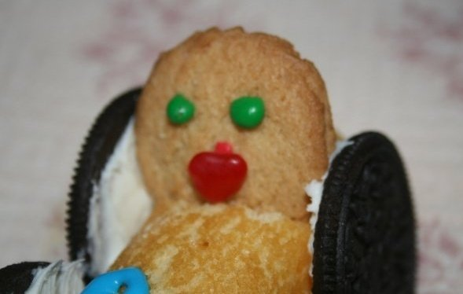
Directions
- Poke holes in Oreo cookies with toothpick. Insert toothpicks through Twinkie in front and back about half way up. Put Oreo wheels on toothpicks.
- Glue (using white frosting) red hots (tail lights) on back, mini marshmallows (squish first) or yellow M&M's headlights on front, and ½ vanilla wafer on top for steering wheel.
- Decorate the car with tubes of frosting.
Twinkie School Bus
Cascade Pacific Council
Ingredients:
- 1 Twinkie
- 4 cookie crisp cereal pieces
- 1/2 vanilla wafer
- 2 mini marshmallows
- 2 red hots
- Frosting (for glue)
Directions:
- Place Twinkie in the center of a small paper plate. Using the frosting “glue”:
- The cookie crisp cereal pieces to the Twinkie for wheels,
- The vanilla wafer for the steering wheel,
- The marshmallows for headlights placing a red hot in the center of each marshmallow to complete the lights.
Snowball VW Bug Car
Cascade Pacific Council
Use the same method as above,
use Snowballs instead of Twinkies.
Pinewood Derby Celery Racers
Cascade Pacific Council
Ingredients:
- Celery
- Canned Cheese
- Carrots
- Raisins
- Toothpicks
Directions:
- Cut celery into 6” lengths.
- Slice carrots in 1/8” thick pieces.
- Pile cheese into center of the celery and
- Top off with a raisin for the drivers head.
- At each end of the celery stick use a toothpick as an axle and wheels.
You can use Peanut Butter instead of
Canned Cheese if desired.
Cookie Wheels
Cascade Pacific Council
Ingredients:
- Cookies (any small kind the size of Oreos)
- Prepared frosting
- Colored sprinkles or mini chocolate chips
Directions
Sandwich two cookies together using frosting as glue. Frost the edges of the "wheel" and roll in sprinkles or mini chocolate chips.
Zesty Appetizer Wheels
Cascade Pacific Council
Ingredients:
- 12 slices hard salami
- 1 (8 ounce) can crescent rolls
- 1/3 cup tbsps grated parmesan cheese
- 2 teaspoons Italian seasoning
Directions
- Preheat oven to 3 50°F.
- Open the dough to 2 rectangles,
- Press the perforation to seal.
- Sprinkle each rectangle with 3 tbsp parmesan and 1 tsp Italian seasoning.
- Lay 6 slices salami along the side of the rectangle.
- Roll the dough up and pinch the ends.
- Cut each roll into 8 slices.
- Place on cookie sheet and bake for 13 min or until golden brown.
- You can substitute 24 pepperoni for 12 salami slices.
“Wheelie Cookies”
Alice, Golden Empire Council
Ingredients:
- 1-1/2 cup all purpose flour
- ½ cup softened margarine or butter
- ¼ teaspoon of powdered sugar
- ½ teaspoon of baking powder
- 2 Tablespoons of milk
- 1 cup of pie filling or jam
Directions:
- Pre-heat the oven to 375 degrees.
- Mix flour, butter or margarine, powdered sugar, baking powder and a little milk. (Only enough for the dough to form – if the dough seems dry, mix in 1 teaspoon of milk at a time)
- Divide the dough into six equal parts.
- Shape each part into a ball, place on an ungreased cookie sheet and flatten slightly.
- Make an indentation about 1-3/4” across and ¾” deep in the center of each cookie – I use my finger or thumb.
- Fill each indentation with about 2 Tablespoons of either pie filling or jam.
- Bake until edges begin to brown, about 20-25 minutes.
- This recipe makes 6 “Wheelies” – easy to double or even triple!
Racing Car Treat
Alice, Golden Empire Council
Each boy can build his own racing car.
- Begin with a hot dog bun sliced apart, with a slice of cheese in between – this makes racing “stripes” on the side of the “car.”
- You could add a hot dog, or slice a hot dog horizontally to make another “stripe” down the side of the car.
- Make wheels out of carrot slices and attach with toothpicks.
- Use pimento strips to outline the driver’s seat.
- The “driver” is an olive on a toothpick.
- Pickles can make bumpers and another carrot slice can make the steering wheel.
Car
Cascade Pacific Council
Use a Hostess Snowball or scoop of ice cream rolled in graham cracker crowns for body, stick red cinnamon candies, M and Ms etc., to define windows and doors. Use Oreo cookies for the wheels.
Wheels
Cascade Pacific Council
Split an English muffin in half, spread with tomato sauce and sprinkle with oregano and basil. Top with grated cheese, pepperoni or any other pizza toppings of your choice. Toast in oven until cheese is melted.
Frozen Wheels
Cascade Pacific Council
Ingredients:
- Chocolate chip cookies
- Chocolate or vanilla ice cream, softened
- Colored sprinkles 01 mini chocolate chips
Directions
- Create a wheel by sandwiching ice cream between two cookies.
- Roll the edges of the "wheel" in colored sprinkles or mini chocolate chips.
- Freeze until ready to eat.
Speedy Donuts
Cascade Pacific Council
Ingredients:
- 1 pkg. ready to bake biscuits
- 1 c. oil
- Sugar & cinnamon mixed in a brown paper bag
Directions
- Separate biscuits and cut a hole in center (or pull apart with fingers to form a ring).
- The following step is to be done by adults only or maybe an older Den Chief: Drop in hot oil and turn to brown on both sides and remove from oil.
- Toss in the sugar and cinnamon mixture. They are ready to eat!!
Hamburger Surprise
Cascade Pacific Council
Ingredients:
- Vanilla wafers (buns)
- Small York Peppermint Patties (burgers)
- Green coconut (lettuce)
- White frosting, colored yellow and red (ketchup and mustard)
Directions
- Place York Peppermint Patty on vanilla wafer.
- Frost with "mustard," and "ketchup," and top with "lettuce."
- Place 2nd wafer on top, Squeeze gently for a JUICY hamburger surprise.
Nuts and Bolts
Cascade Pacific Council
Ingredients:
- ½ C Margarine
- 1 ¼ tsp seasoned salt
- 2 C Corn Chex
- 2 C Rice Chex
- 2 C Cheerios
- 2 C Pretzels
- 4 ½ tsp Worcestershire sauce
- 1 C mixed nuts
Directions
Melt margarine in a large pan in the oven. Add seasoned salt and stir. Mix in remaining ingredients and stir until coated. Bake for 1 hour at 250 degrees Fahrenheit. Stir every 15 minutes.
Nutty Putty
Cascade Pacific Council
Ingredients:
- 3 ½ cups peanut butter
- 4 cups powdered sugar
- 3 ½ cups honey
- 4 cups dried milk powder
Directions
Mix ingredients together. Divide into 10 to 15 portions. Store extra portions in plastic bags in refrigerator or freezer. This treat can serve as fun dough. With clean hands, children can mold and shape into animals, flowers, and other objects while they eat it.
Other Refreshment Ideas:
Cascade Pacific Council
- Car-shaped cake, or one shaped like a figure-8 racetrack.
- Red Stoplights - red Jell-o jigglers
- Or Stop and Go Lights - red and green jigglers
- Graham Crackers with red, green and yellow M&M's to make stoplights.
- Race Track Snack: Oreo cookie cereal (tires), Cinnamon Toast Crunch cereal (available with a checkered flag design at the time), M&M's...red ones, green ones, yellow ones...(traffic light colors) and pretzels called KIDZELS which are shaped like various vehicles.

POW WOW EXTRAVAGANZAS
Southern NJ Council
Improving Your 'Scoutability"
Postponed - University of Scouting under development

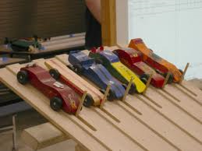

WEB SITES
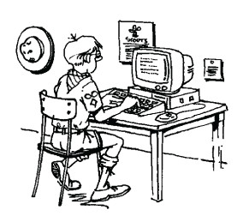

More "Web Sites" are in the Pack and Leader Hints Edition Dave
Pinewood Derby Web Sites
Wendy, Chief Seattle Council
- Official Pinewood Derby Website -
Boy Scouts of America
http://www.pinewoodderby.org/
- www.USScouts.org Pinewood Reference Pages
http://usscouts.org/pinewood.asp
- Pinewood Derby Pack Night Ideas
There are a lot Car related and Pinewood Derby related ideas in the
December 2007 Edition of Baloo's Bugle, "Cub Scout Car Show."
- Pope's Pinewood Pages Portal
The Pope's have created their site by selecting information so that it does not duplicate what you can find elsewhere on the Internet. It includes original material on Pinewood Derby race management and race car design, 2-liter pop bottle rocket launcher, Cub Scout Roundtable, and other Scouting topics, as well as a few personal insights by Stan and Barb Pope.
Pope's Pages -
http://stanpope.net/pwportal.html
The book, " "Learn to Build A Winner"
http://stanpope.net/lbw_apl.html
- Crafts
Art-rageous cars: http://jas.familyfun.go.com/arts-and-crafts?page=CraftDisplay&craftid=11738
Toilet Tube Racer: http://jas.familyfun.go.com/arts-and-crafts?page=CraftDisplay&craftid=11416
- Car Party Ideas:
http://familyfun.go.com/parties/birthday/feature/famf1001_racecarbday/
- Pinewood Derby Driver’s License:
http://www.pinewoodpro.com/pinewood-derby-car-racing-license.htm
- Pinewood Derby Activities Manual by "A Bunch of Old Guys and a Track"
http://grandprix-race-central.com/downloads/activities_booklet.pdf
- Link to lots of pinewood derby websites with useful information:
http://www.scoutingthenet.com/Derbys/,
http://www.three-peaks.net/pinecar.htm

ONE LAST THING
Pinewood Derby Race
Peggy Porter
www.usscouts.org
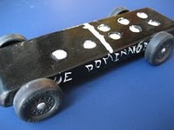
My son Gilbert was eight years old and had been in Cub Scouts only a short time. During one of his meetings he was handed a sheet of paper, a block of wood and four tires and told to return home and give all to "dad".
That was not an easy task for Gilbert to do. Dad was not receptive to doing things with his son. But Gilbert tried. Dad read the paper and scoffed at the idea of making a pine wood derby car with his young eager son. The block of wood remained untouched as the weeks passed. Finally, mom stepped in to see if she could figure this all out. The project began.
Having no carpentry skills,I decided it would be best if I simply read the directions and let Gilbert do the work. And he did. I read aloud the measurements, the rules of what we could do and what we couldn't do. Within days his block of wood was turning into a pinewood derby car. A little lopsided, but looking great (at least through the eyes of mom). Gilbert had not seen any of the other kids' cars and was feeling pretty proud of his "Blue Lightning", the pride that comes with knowing you did something on your own.
Then the big night came. With his blue pinewood derby car in his hand and pride in his heart we headed to the big race. Once there my little one's pride turned to humility. Gilbert's car was obviously the only car made entirely on his own. All the other cars were a father-son partnership, with cool paint jobs and sleek body styles made for speed.
A few of the boys giggled as they looked at Gilbert's lopsided, wobbly, unattractive vehicle. To add to the humility, Gilbert was the only boy without a man at his side. A couple of the boys who were from single parent homes at least had an uncle or grandfather by their side, Gilbert had "mom".
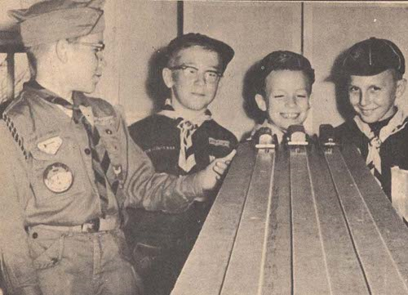
As the race began it was done in elimination fashion. You kept racing as long as you were the winner. One by one the cars raced down the finely sanded ramp. Finally it was between Gilbert and the sleekest, fastest looking car there. As the last race was about to begin, my wide eyed, shy eight year old asked if they could stop the race for a minute, because he wanted to pray. The race stopped.
Gilbert went to his knees clutching his funny looking block of wood between his hands. With a wrinkled brow he set to converse with his Father. He prayed in earnest for a very long minute and a half. Then he stood, smile on his face and announced, 'Okay, I am ready."
As the crowd cheered, a boy named Tommy stood with his father as their car sped down the ramp. Gilbert stood with his Father within his heart and watched his block of wood wobble down the ramp with surprisingly great speed and rushed over the finish line a fraction of a second before Tommy's car. Gilbert leaped into the air with a loud "Thank You" as the crowd roared in approval.
The Scout Master came up to Gilbert with microphone in hand and asked the obvious question, "So you prayed to win, huh, Gilbert?" To which my young son answered, "Oh, no sir. That wouldn't be fair to ask God to help you beat someone else. I just asked Him to make it so I wouldn't cry when I lost." -----
Children seem to have a wisdom far beyond us. Gilbert didn't ask God to win the race, he didn't ask God to fix the outcome. Gilbert asked God to give him strength in the outcome. When Gilbert first saw the other cars he didn't cry out to God, "No fair, they had a father's help!" No, Gilbert went to his Heavenly Father for strength.
Perhaps we spend too much of our prayer time asking God to rig the race, to make us number one, or too much time asking God to remove us from the struggle, when we should be seeking God's strength to get us through the struggle.
"I can do all things through Christ which strengtheneth me." Philippians 4:13.
Gilbert's simple prayer spoke volumes to those present that night. He never doubted that God would indeed answer his request. He didn't pray to win, thus hurt someone else, he prayed that God supply the grace to lose with dignity. Gilbert, by his stopping the race to speak to his Father also showed the crowd that he wasn't there without a "dad", but he also went away a winner that night, with his Father at his side.
May we all learn to pray this way.
