a. Explain to your counselor the most likely hazars you may encounter while participating in fishing activities, and what you should do to anticipate, help prevent, mitigate, and respond to these hazards.
b. Discuss the prevention of and treatment for the following health concerns that could occur while fishing, including cuts, scratches, puncture wounds, insect bites, hypothermia, dehydration, heat exhaustion, heatstroke, and sunburn.
Cuts:
Scratches:
Puncture wounds:
Insect bites:
Hypothermia:
Dehydration:
Heat exhaustion:
Heatstroke:

Sunburn:.
c. Explain how to remove a hook that has lodged in your arm.
d. Name and explain five safety practices you should always follow while fishing.
2. Discuss the differences between two types of fishing outfits.
Type 1:
Type 2:
Differences:

Point out and identify the parts of several types of rods and reels. Explain how and when each would be used. Review with your counselor how to care for this equipment.
 | Example of a Spinning Rod & Reel | Example of a Salt Water Trolling Rod & Reel
 |  | 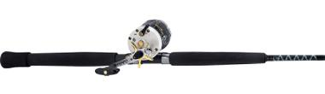
How used:
When used:
Care:
 | Example of an Ice Fishing Rod & Reel | Example of a Fly Fishing Rod & Reel
 |  | 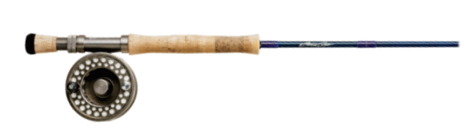
How used:
When used:
Care:

3. Demonstrate the proper use of two different types of fishing equipment.
4. Demonstrate how to tie the following knots: improved clinch knot, Palomar knot, uni knot, uni to uni knot, and arbor knot. Explain how and when each knot is used.
Improved clinch,
Palomar knot,
Uni knot
Uni to uni knot
arbor knot.
5. Name and identify five Artificial Lures and five Natural Baits and explain how to fish with them.
Artificial Lures: (Here are some examples)
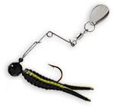 | 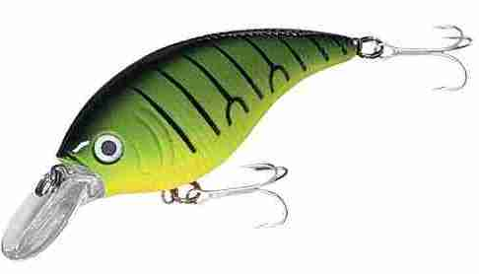 | 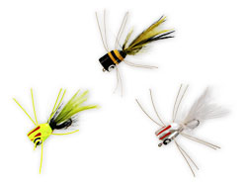 | 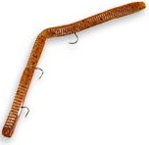 | 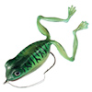

 | Artificial Lures | How to fish with it:
1.
2.
3.
4.
5.

 | Natural Baits | How to fish with it:
1.
2.
3.
4.
5.
Explain why bait fish are not to be released.

6. Do the following:
a. Explain the importance of practicing Leave No Trace techniques. Discuss the positive effects of Leave No Trace on fishing resources.
b. Discuss the meaning and importance of catch and release.
Describe how to properly release a fish safely to the water.
7. Obtain and review a copy of the regulations affecting game fishing where you live. Explain why they were adopted and what you accomplish by following them.
8. Explain what good outdoor sportsmanlike behavior is and how it relates to anglers.

Tell how the Outdoor Code of the Boy Scouts of America relates to a fishing enthusiast, including the aspects of littering, trespassing, courteous behavior, and obeying fishing regulations.
How it relates to fishing:
Littering:
Trespassing:
Courteous behavior:
Obeying fishing regulations:
9. Catch at least one fish and identify it.
Identify the fish
10. If regulations and health concerns permit, clean and cook a fish you have caught.
Otherwise, acquire a fish and cook it. (You do not need to eat your fish.)

When working on merit badges, Scouts and Scouters should be aware of some vital information in the current edition of the Guide to Advancement (BSA publication 33088). Important excerpts from that publication can be downloaded from http://usscouts.org/advance/docs/GTA-Excerpts-meritbadges.pdf.
You can download a complete copy of the Guide to Advancement from http://www.scouting.org/filestore/pdf/33088.pdf.

Wilderness Use Policy of the Boy Scouts of America
All privately or publicly owned backcountry land and designated wildernesses are included in the term “wilderness areas” in this policy. The Outdoor Code of the Boy Scouts of America and the principles of Leave No Trace apply to outdoor behavior generally, but for treks into wilderness areas, minimum-impact camping methods must be used. Within the outdoor program of the Boy Scouts of America, there are many different camping-skill levels. Camping practices that are appropriate for day outings, long-term Scout camp, or short-term unit camping might not apply to wilderness areas. Wherever they go, Scouts need to adopt attitudes and patterns of behavior that respect the rights of others, including future generations, to enjoy the outdoors.
- In wilderness areas, it is crucial to minimize human impact, particularly on fragile ecosystems such as mountains, lakes and streams, deserts, and seashores. Because our impact varies from one season of the year to the next, it becomes important for us to adjust to these changing conditions to avoid damaging the environment.
- The Boy Scouts of America emphasizes these practices for all troops, teams, and crews planning to use wilderness areas:
- Contact the landowner or land-managing agency (USDA Forest Service, National Park Service, Bureau of Land Management, U.S. Fish and Wildlife Service, U.S. Army Corps of Engineers, state and private agencies, etc.) well before an outing to learn the regulations for that area, including group size limits, to obtain required permits and current maps, and to discuss ways Scouts can fulfill the expectations of property owners or land managers.
- Obtain a tour permit (available through local council service centers), meet all of its conditions, and carry it during the trip.
- Review the appropriate BSA safety literature relating to planned activities. (See Safe Swim Defense, Safety Afloat, Climb On Safely, and Trek Safely.) Also see the Guide to Safe Scouting on the BSA Web site at http://www.scouting.org/pubs/gss/toc.html for more information on current BSA policies and procedures for ensuring safe activities, as well as the Fieldbook Web site at http://www.bsafieldbook.org.
- Match the ruggedness of high-adventure experiences to the skills, physical ability, and maturity of those taking part. Save rugged treks for older unit members who are more proficient and experienced in outdoor skills.
- Conduct pretrip training for your group that stresses proper wilderness behavior, rules, and skills for all of the conditions that may be encountered, including lightning, missing person, wildfire, high winds, flooding, and emergency medical situations.
- Participate in training in how to apply the principles of Leave No Trace, and be proficient and experienced in the leadership and skills required for treks into wilderness areas.
- Adhere to the principles of Leave No Trace.

Outdoor Code

As an American, I will do my best to—
Be clean in my outdoor manners. I will treat the outdoors as a heritage. I will take care of it for myself and others. I will keep my trash and garbage out of lakes, streams, fields, woods, and roadways.
Be careful with fire. I will prevent wildfire. I will build my fires only when and where they are appropriate. When I have finished using a fire, I will make sure it is cold out. I will leave a clean fire ring, or remove all evidence of my fire.
Be considerate in the outdoors. I will treat public and private property with respect. I will follow the principles of Leave No Trace for all outdoor activities.
Be conservation-minded. I will learn about and practice good conservation of soil, waters, forests, minerals, grasslands, wildlife, and energy. I will urge others to do the same.

The Principles of Leave No Trace

1. Plan Ahead and Prepare
2. Travel and Camp on Durable Surfaces
3. Dispose of Waste Properly (Pack It In, Pack It Out)
4. Leave What You Find
5. Minimize Campfire Impacts
6. Respect Wildlife
7. Be Considerate of Other Visitors

