<http://www.USScouts.Org> • <http://www.MeritBadge.Org>

Please submit errors, omissions, comments or suggestions about this **workbook** to: [Workbooks@USScouts.Org](mailto:Workbooks@usscouts.org?subject=Merit%20Badge%20Workbooks)

Comments or suggestions for changes to the **requirements** for the **Belt Loop or Pin** should be sent to: [Advancement.Team@Scouting.Org](mailto:Advancement.Team@Scouting.Org)

Cub Scout’s Name: Pack No. :

Webelos Scouts that earn the Chess Belt Loop while a Webelos Scout   
also satisfy requirement 8 for the Scholar Activity Badge.

#### Cub Scout Chess Belt Loop *(See the* *Pin Requirements* *below.)*

**Complete these three requirements:**

⬜ 1. Identify the chess pieces and set up a chess board for play.

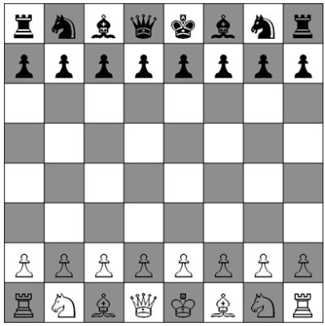

⬜ 2. Demonstrate the moves of each chess piece to your den leader or adult partner.   
*(Editor’s Note: Put dots on the spaces you could move to in each of the following diagrams.)*

|  |  |  |
| --- | --- | --- |
| king |  | queen |
| **King** |  | **Queen** |
| bishop |  | knight |
| **Bishop** |  | **Knight** |
| rook |  | pawn |
| **Rook** |  | **Pawn** |

⬜ 3. Play a game of chess.

#### Cub Scout Chess Pin

**Earn the Cub Scout Chess belt loop, and complete five of the following requirements:**

⬜. 1. Demonstrate basic opening principles (such as development of pieces, control center, castle, don't bring queen out too early, don't move same piece twice).

⬜. Development of pieces ⬜. Don't bring queen out too early

⬜. Control center ⬜. Don't move same piece twice

⬜. Castle

⬜ 2. Visit a chess tournament and tell your den about it.

|  |
| --- |
|  |

⬜ 3. Participate in a pack, school, or community chess tournament.

⬜ 4. Solve a pre-specified chess problem (e.g., "White to move and mate in three") given to you by your adult partner.

⬜ 5. Play five games of chess.

|  |  |  |  |
| --- | --- | --- | --- |
|  | Date | Opponent | Who won? |
| 1. |  |  |  |
| 2. |  |  |  |
| 3. |  |  |  |
| 4. |  |  |  |
| 5. |  |  |  |

⬜ 6. Play 10 chess games via computer or on the Internet. (*Get your parent’s permission first*.)

|  |  |  |  |  |  |
| --- | --- | --- | --- | --- | --- |
|  | Date | Who won? |  | Date | Who won? |
| 1. |  |  | 6. |  |  |
| 2. |  |  | 7. |  |  |
| 3. |  |  | 8. |  |  |
| 4. |  |  | 9. |  |  |
| 5. |  |  | 10. |  |  |

⬜ 7. Read about a famous chess player. Tell your den or an adult family member about that player's life.

|  |
| --- |
|  |

⬜ 8. Describe U.S. Chess Federation ratings for chess players.

|  |
| --- |
|  |

⬜ 9. Learn to write chess notation and record a game with another Scout.

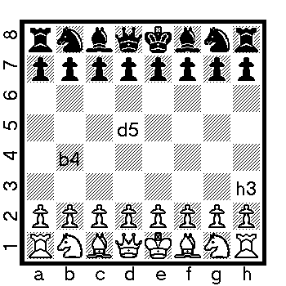**Algebraic System**

**Symbols**

K = King

Q = Queen

R = Rook

B = Bishop

N = kNight

x = capture

+ = check

++ = doublecheck

# = checkmate

O-O = castles short on the King's side

O-O-O = castles long on the Queen’s side

1-0 white won

0-1 black won

.5-.5 draw

Record a game with another Scout

|  |
| --- |
|  |

⬜ 10. Present a report about the history of chess to your den or family.

|  |
| --- |
|  |

**Requirement resources can be found here:**

[http://www.meritbadge.org/wiki/index.php/Cub_Scout_Chess#Requirement resources](http://www.meritbadge.org/wiki/index.php/Cub_Scout_Chess#Requirement_resources)

**Important excerpts from the** [***‘Guide To Advancement’***](http://www.scouting.org/filestore/pdf/33088.pdf)**, No. 33088:**

Effective January 1, 2012, the *‘Guide to Advancement’* (which replaced the publication *‘Advancement Committee Policies and Procedures’*) is now the *official* Boy Scouts of America source on advancement policies and procedures.

* **[ Inside front cover, and 5.0.1.4 ] — Unauthorized Changes to Advancement Program**

***No council, committee, district, unit, or individual has the authority to add to, or subtract from, advancement requirements.*** (There are limited exceptions relating only to youth members with disabilities. For details see section 10, “Advancement for Members With Special Needs”.)

* **[ Inside front cover, and 7.0.1.1 ] — The** [***‘Guide to Safe Scouting’***](http://www.scouting.org/scoutsource/HealthandSafety/GSS/toc.aspx) **Applies**

Policies and procedures outlined in the *‘Guide to Safe Scouting’,* No. 34416, apply to all BSA activities, including those related to advancement and Eagle Scout service projects. [Note: Always reference the online version, which is updated quarterly.]

* **[ 4.1.0.3 ]** **] — Who Approves Cub Scout Advancement?**

A key responsibility for den leaders is to implement the core den meeting plans as outlined in the Den & Pack Meeting Resource Guide, No. 34409. For Wolf, Bear, and Webelos advancement, den leaders take the lead in approving requirements, though their assistants, and also parents who help at meetings, may be asked to play the role of “Akela” and assist. Parents sign for requirements that, according to meeting plans and instructions in the handbooks, take place at home. For the Bobcat trail and Tiger Cub achievements, parents (or adult partners) should sign in the boy’s handbook; the den leader then approves as progress is recorded in the den’s advancement record.

* **[ 4.1.0.4 ] — “Do Your Best”**

Advancement performance in Cub Scouting is centered on its motto: “Do Your Best.” When a boy has done this—his very best—then regardless of the requirements for any rank or award, it is enough; accomplishment is noted. This is why den leaders, assistants, and parents or guardians are involved in approvals. Generally they know if effort put forth is really the Cub Scout’s best.

* **[ 4.1.2.2 ]** **— Cub Scout Academics and Sports Program**

More than just a recognition opportunity, this program develops new skills, improves those existing, and otherwise enriches Cub Scouting. Details can be found in the Cub Scout Academics and Sports Program Guide, No. 34299. Activities include subjects like science, video games, collecting, and chess; and sports such as baseball, skateboarding, and table tennis. Each has two levels—a belt loop and a pin. Belt loops, which can be earned more than once, are awarded when each of three requirements is met. Cub Scouts may then continue with additional requirements and earn the pin. Archery and BB gun shooting are included, but can only be conducted at a council presented activity with certified supervisors.

**Additional notes of interest:**

* Tiger Cubs, Cub Scouts, and Webelos Scouts may complete requirements for all Academics and Sports Belt Loops and Pins **(except shooting sports**) in a family, den, pack, school, or community environment. Tiger Cubs must work with their parents or adult partners. Parents and partners do not earn loops or pins.
* **“Akela”** (Pronounced *“Ah-KAY-la”*) **—** Title of respect used in Cub Scouting—any good leader is *Akela*. *Akela* is also the leader and guide for Cub Scouts on the advancement trail. The name comes from Rudyard Kipling's Jungle Book. (See "Law of the Pack.")
* **“Law of the Pack” —**  *The Cub Scout follows Akela.*

*The Cub Scout helps the pack go.*

*The pack helps the Cub Scout grow.*

*The Cub Scout gives goodwill.*